UNITED  NATIONS |  | EP
 |  | UNEP(DTIE)/Hg/WG.Prep/1/INF/1
 | United Nations  Environment  Programme | Distr.: General  28 September 2009  English only

Ad hoc open-ended working group to
prepare for the intergovernmental
negotiating committee on mercury
Bangkok, 19–23 October 2009
Item 4 (c) of the provisional agenda*
Preparations for the work of the intergovernmental negotiating committee to prepare a global legally binding instrument on mercury: information that might assist the work of the intergovernmental negotiating committee

Further information on the United Nations Environment Programme Global Mercury Partnership
Note by the secretariat
Annex I to the present note contains the overarching framework of the United Nations Environment Programme Global Mercury Partnership, while annex II contains the list of partners as at 1 October 2009. The contents of the annexes have been reproduced as received, without formal editing.

Annex I
Overarching framework of the UNEP Global Mercury Partnership

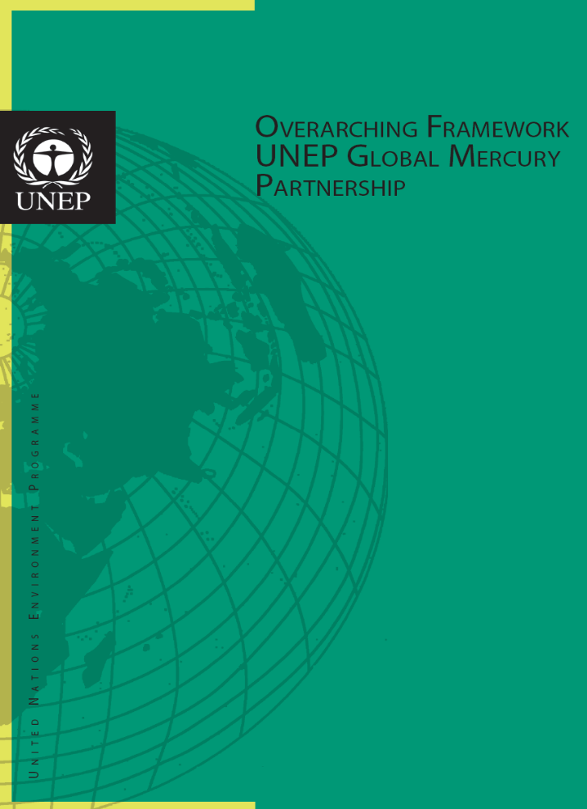

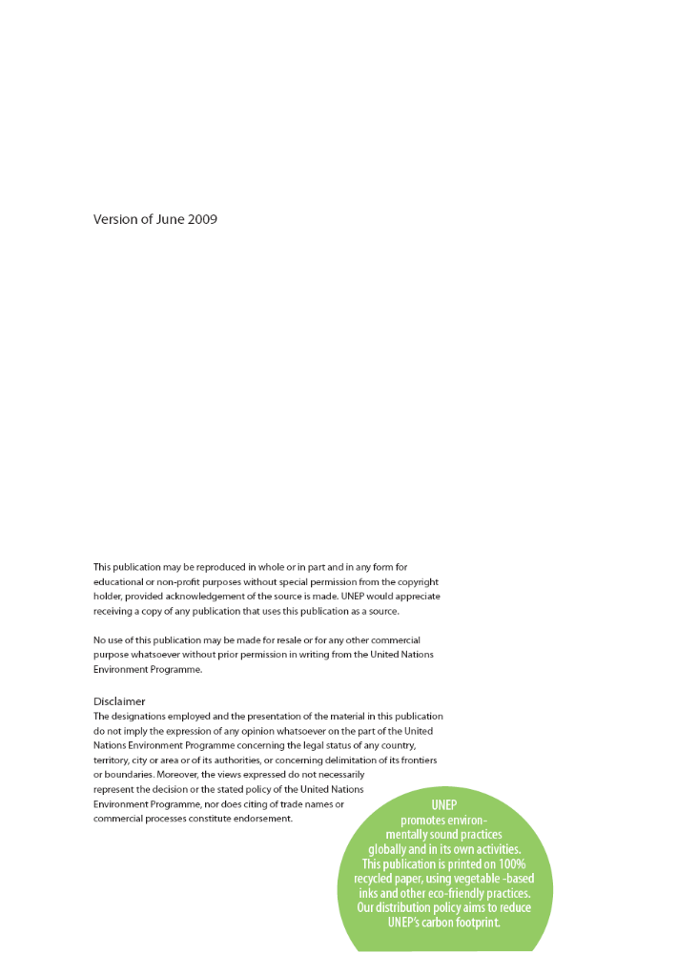

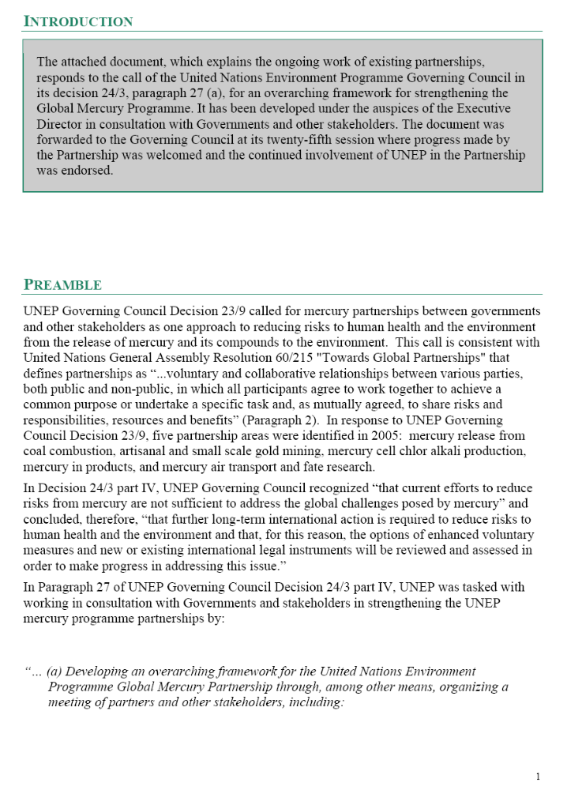

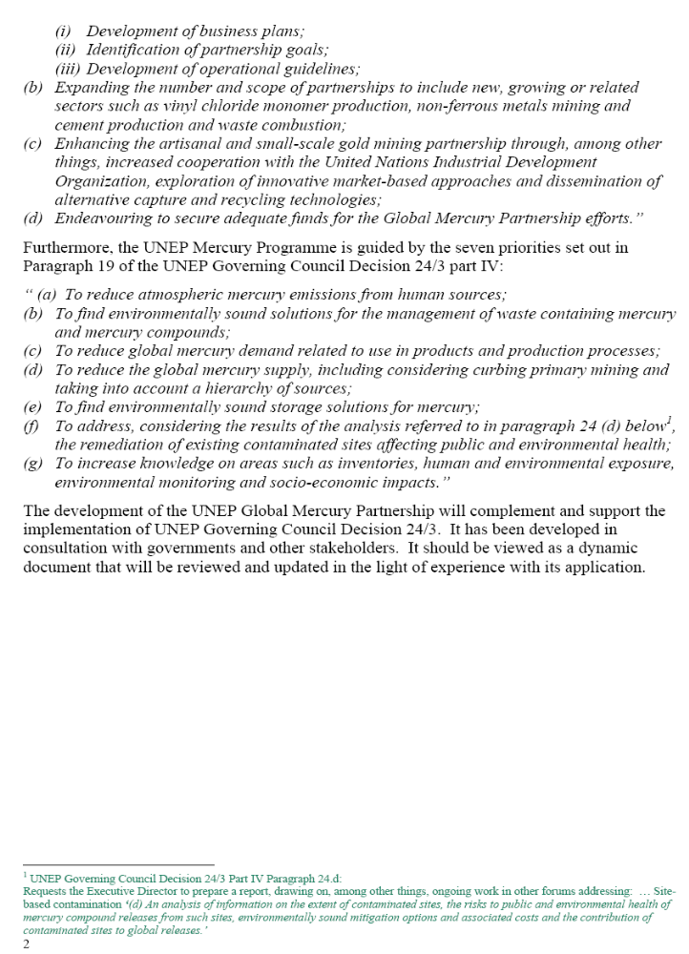

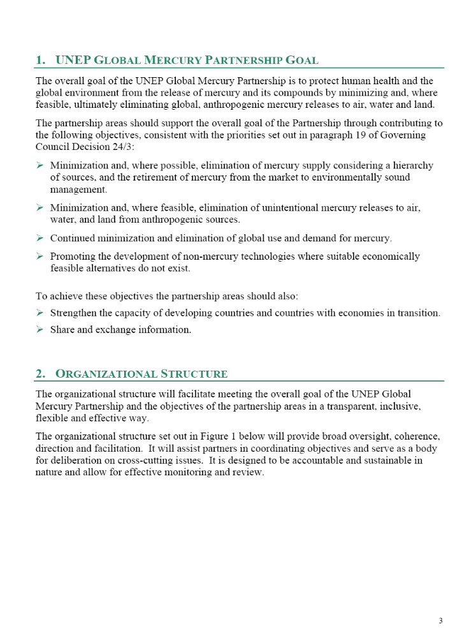

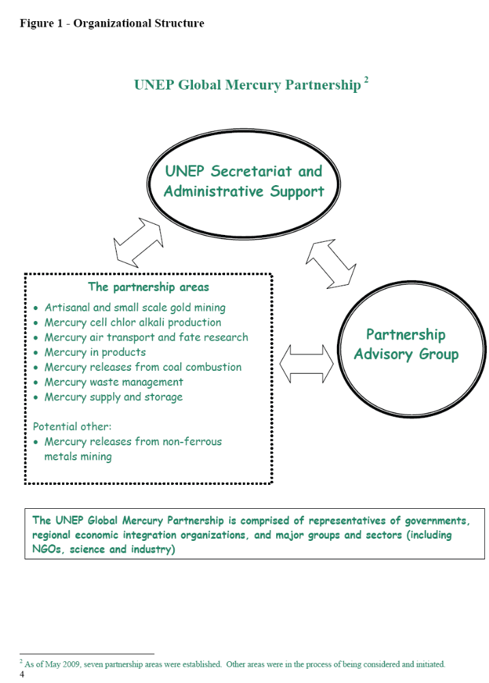

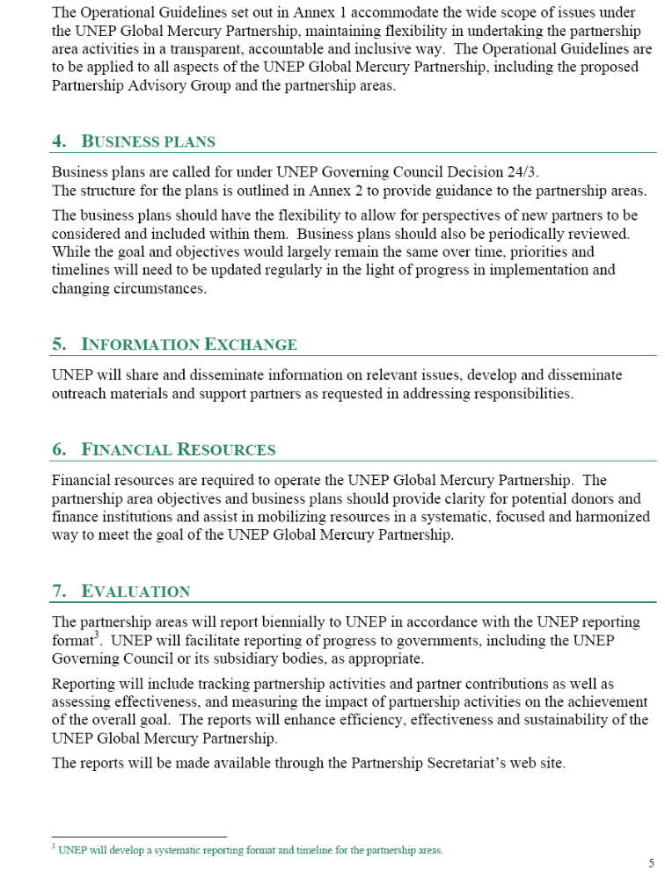



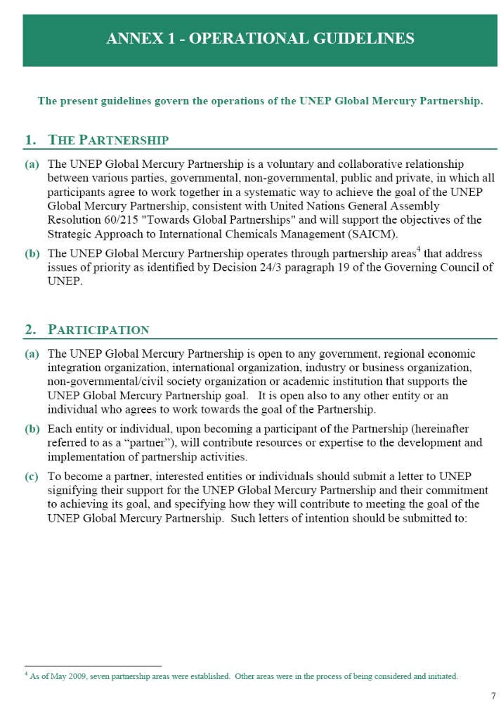

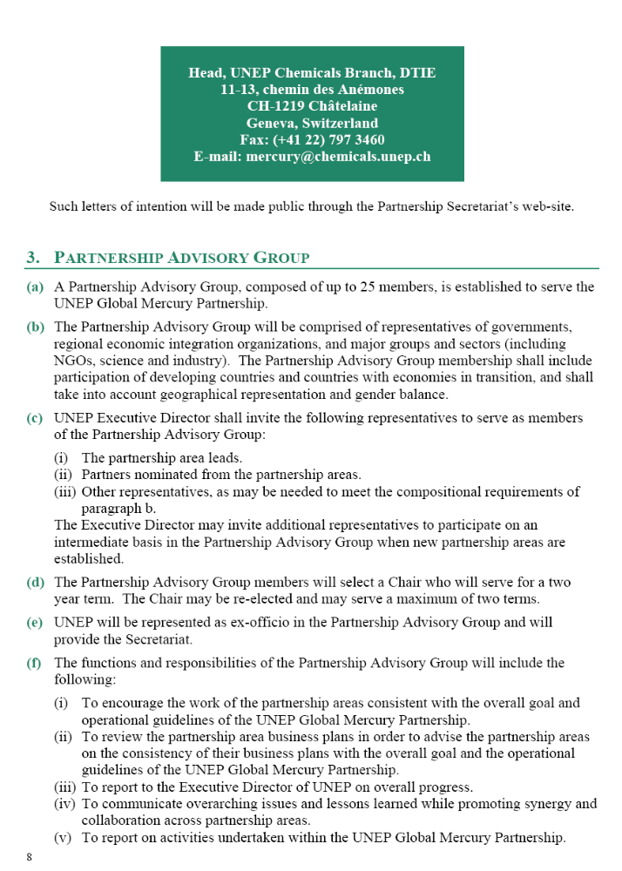

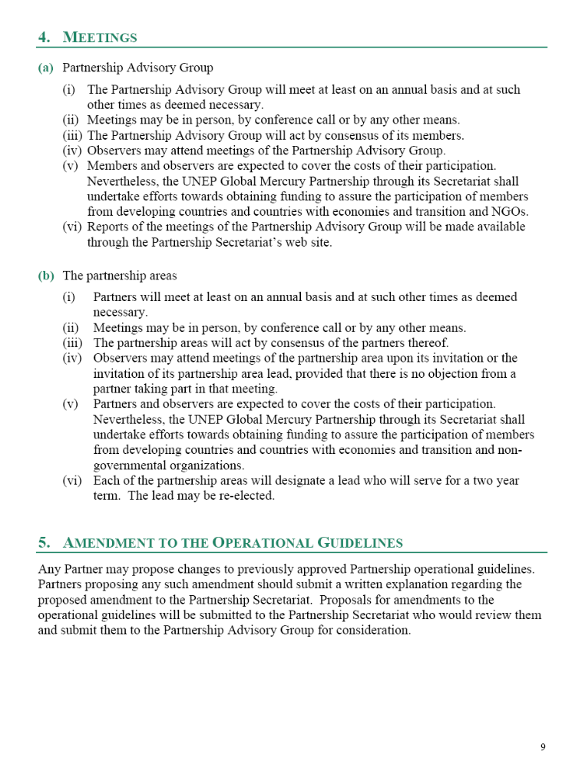

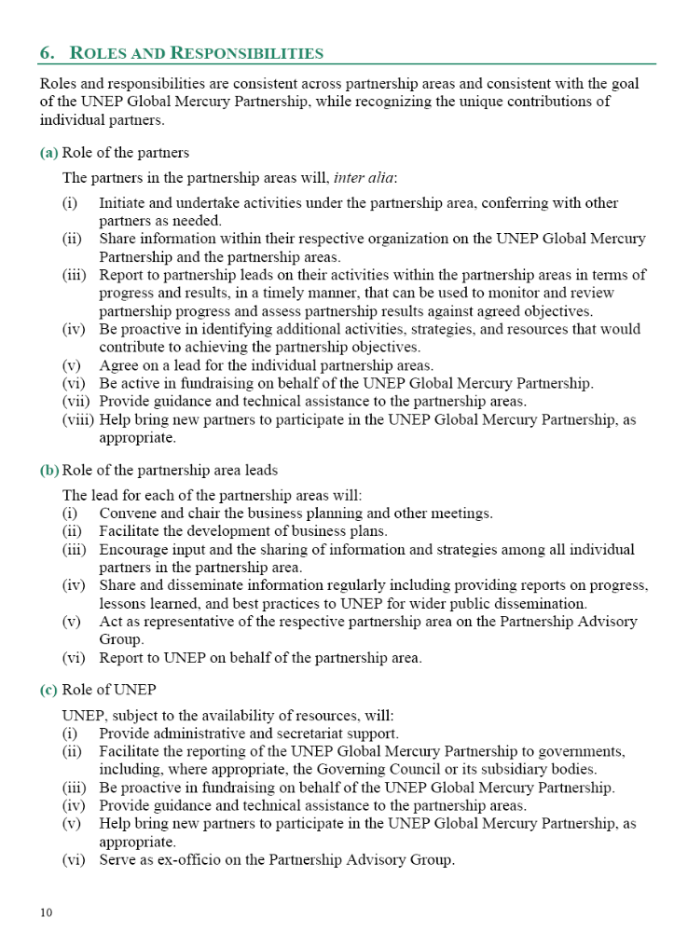

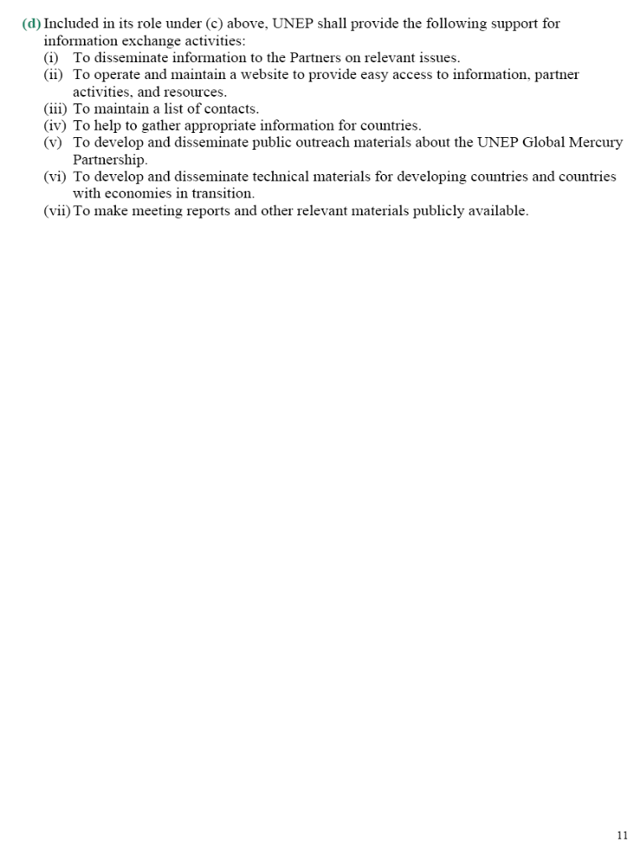



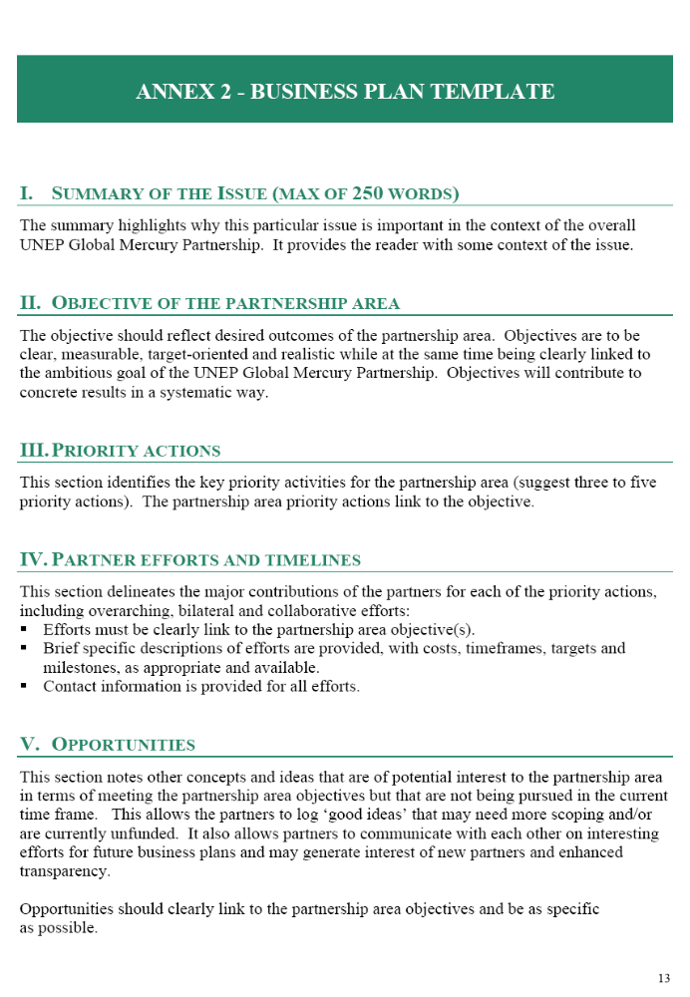

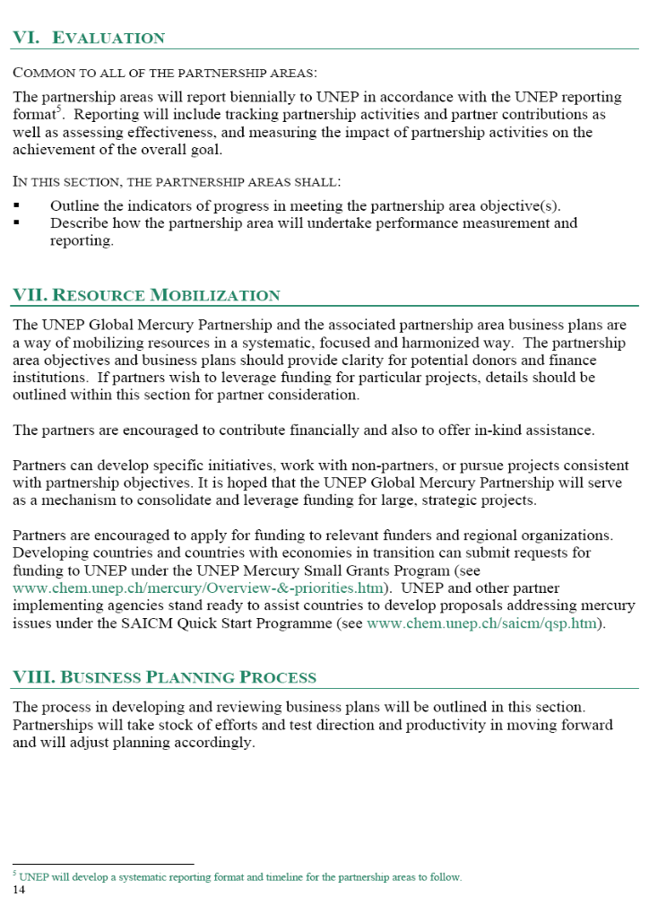

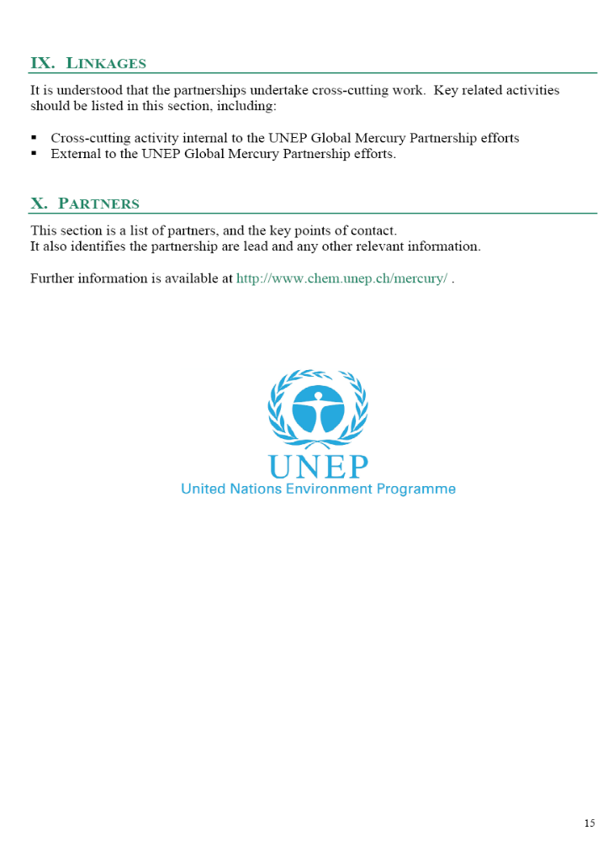



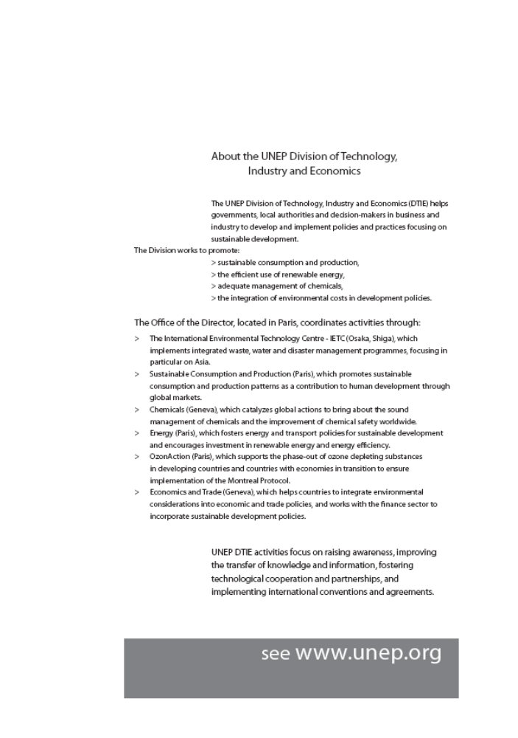

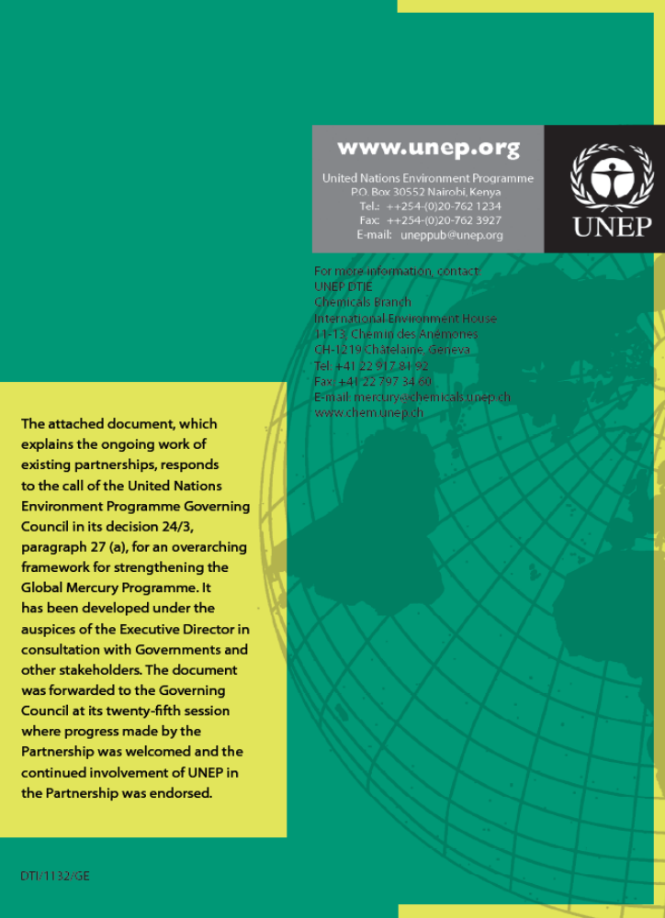

Annex II
Current list of partners
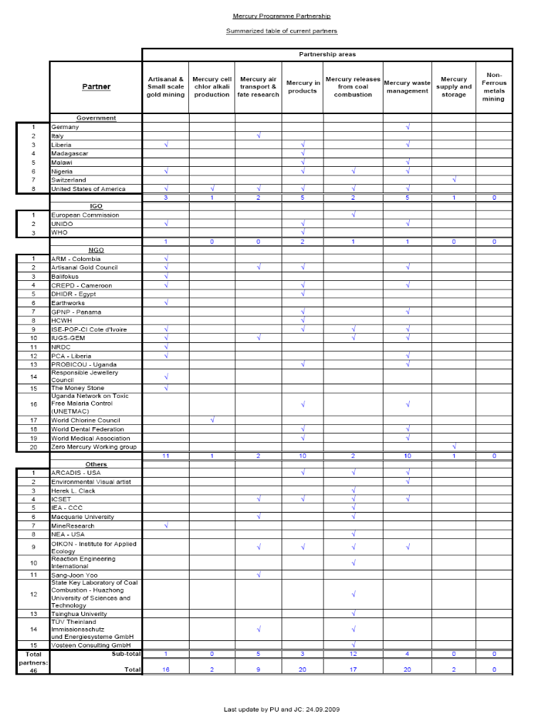

____________

* UNEP(DTIE)/Hg/WG.Prep/1/1.

