UNITED  NATIONS |  | EP
 |  | UNEP(DTIE)/Hg/OEWG.2/INF/1
 | United Nations  Environment  Programme | Distr.: General  23 September 2008  English only
Ad Hoc Open-ended Working Group on Mercury
Second meeting
Nairobi, Kenya
6–10 October 2008
Item 4 of the provisional agenda*
Report on activities under the UNEP mercury programme

Report on atmospheric emissions: update on progress
Note by the Secretariat

- The Governing Council of the United Nations Environment Programme (UNEP), by its decision 24/3 IV, paragraph 24 on chemicals management, requested the Executive Director to prepare a report, drawing on, among other things, ongoing work in other forums addressing:
Atmospheric emission
(a) Best available data on mercury emissions and trends including where possible an analysis by country, region and sector, including a consideration of factors driving such trends and applicable regulatory mechanisms;
(b) Current results from modelling on a global scale and from other information sources on the contribution of regional emissions to deposition which may result in adverse effects and the potential benefits from reducing such emissions, taking into account the efforts of the Fate and Transport partnership established under the United Nations Environment Programme mercury programme.
- UNEP cooperated with the Arctic Monitoring and Assessment Programme working group under the Arctic Council to develop a report focusing on the anthropogenic atmospheric emissions of mercury.
- The Executive Director, in his letter of 24 April 2007 to Governments and intergovernmental and non-governmental organizations, requested information to assist in preparing the report. Information submitted is available on the mercury programme website (http://www.chem.unep.ch/MERCURY/), and was used in preparing the draft report.
- Input from the mercury air transport and fate research partnership area under the UNEP Global Mercury Partnership has come through the direct involvement of experts as co-authors and through the partnership draft report made available in mid-March 2008. The work has also built, where possible, on work undertaken for other forums that is directly relevant to this context, together with scientific peer-reviewed literature.
- The draft report was made available for comment via the website in June 2008. Comments received are under consideration and a revised version of both the draft UNEP report and the draft detailed technical report will be posted on the website.
- The draft executive summary has been provided in the annex to the present note for the information of the working group at its second meeting. It is presented without formal editing.
- The final report will be submitted to Governing Council at its twenty-fifth meeting.

Annex
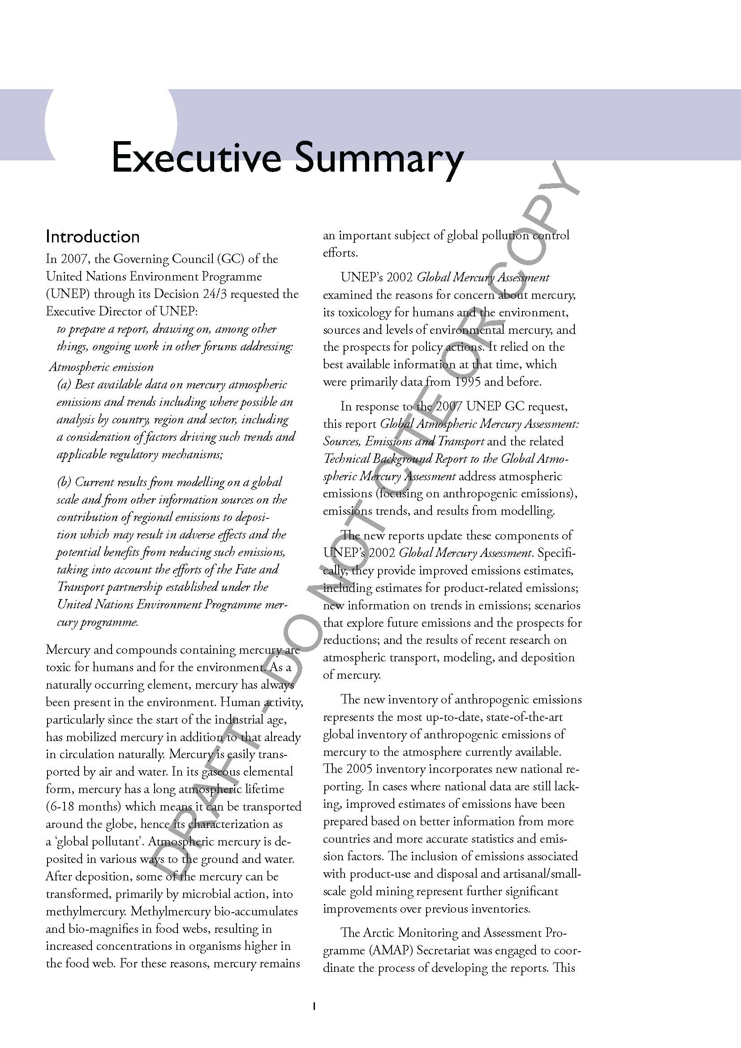

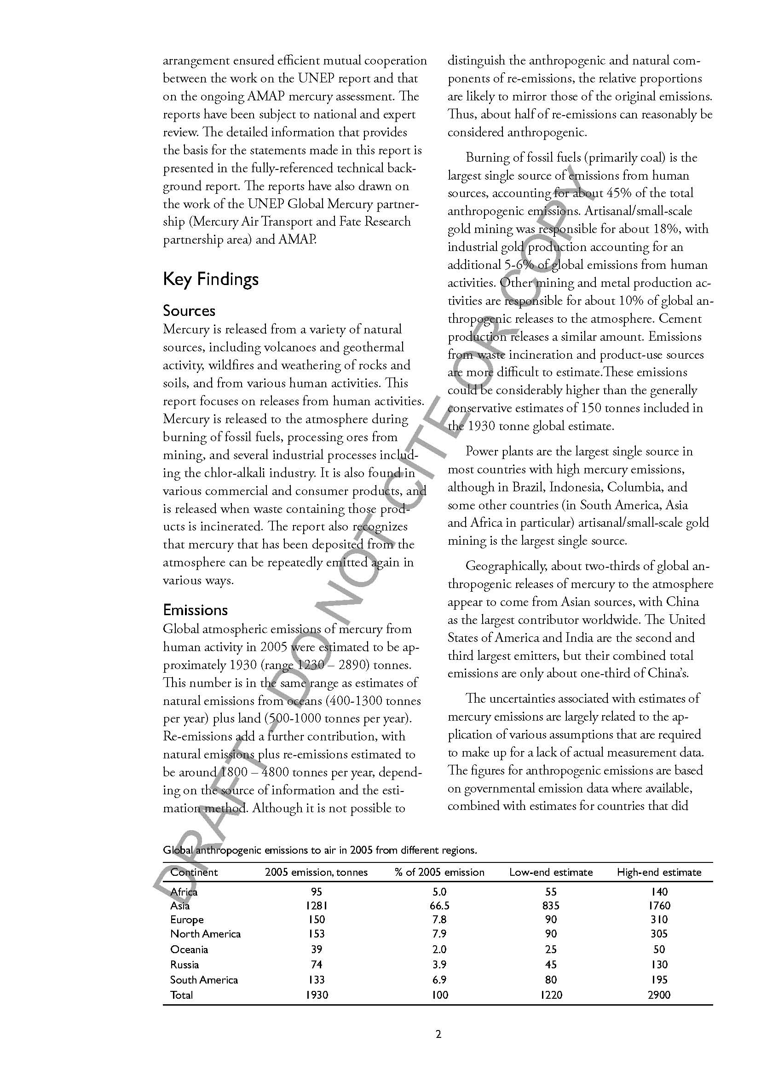
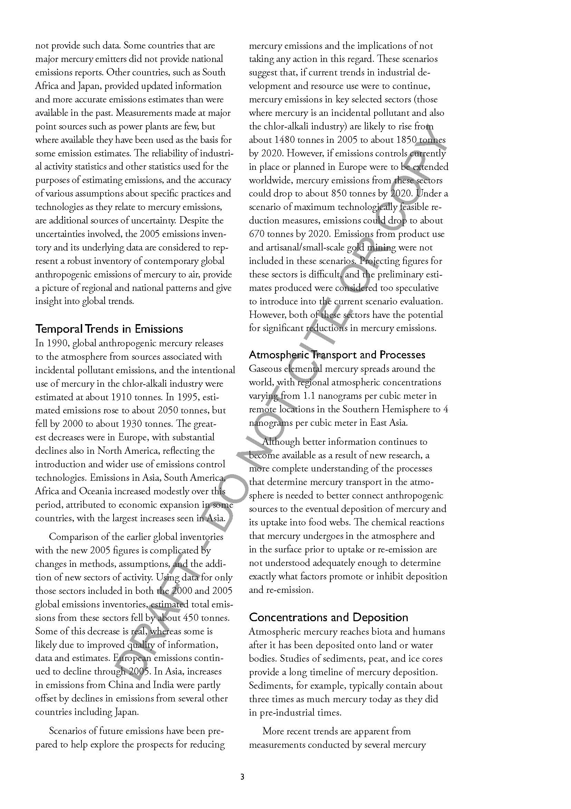

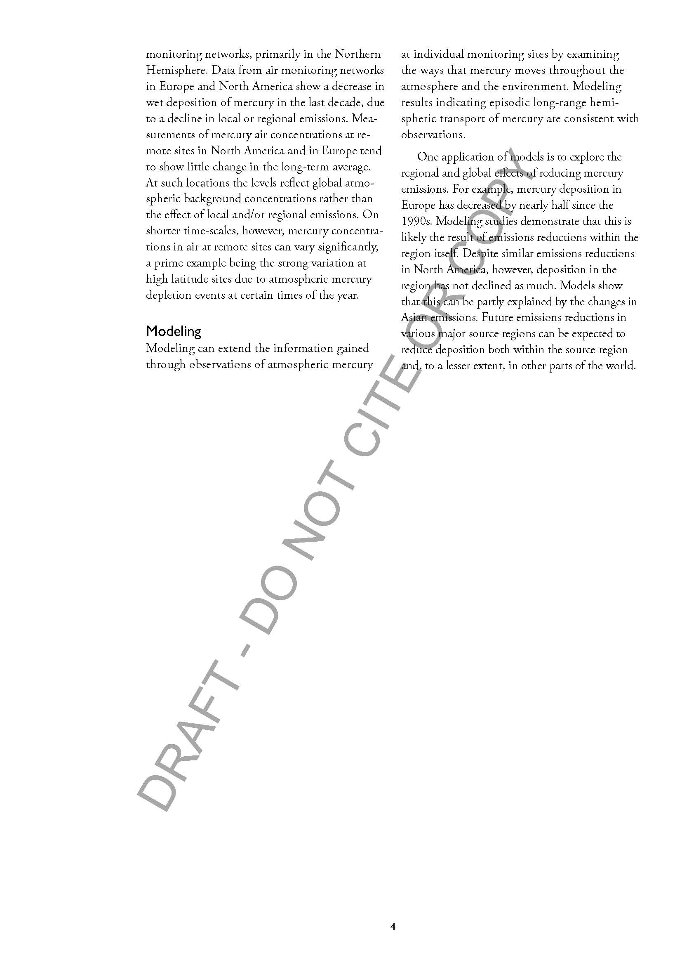

* UNEP(DTIE)/Hg/OEWG.2/1.

