UNITED  NATIONS |  | MC
 |  | UNEP/MC/COP.2/INF/2
 | United Nations  Environment  Programme | Distr.: General  10 October 2018  English only
Conference of the Parties to the
Minamata Convention on Mercury
Second meeting
Geneva, 19–23 November 2018
Item 6 of the provisional agenda*
Programme of work and budget
Report on the activities of relevant international bodies
Note by the Secretariat
- In paragraph 2 (c) of article 24, the Minamata Convention on Mercury includes among the functions of the secretariat coordination, as appropriate, with the secretariats of relevant international bodies, particularly other chemicals and waste conventions.
- In its resolution on matters pertaining to other international bodies (UNEP(DTIE)/Hg/CONF/4, annex I), the Conference of Plenipotentiaries on the Minamata Convention on Mercury invited international bodies such as the World Health Organization, the International Labour Organization and the World Customs Organization to cooperate closely with the intergovernmental negotiating committee to prepare a global legally binding instrument on mercury and the Conference of the Parties to the Minamata Convention to support the implementation of the Convention, particularly article 16, as appropriate, and to provide information to the Conference of the Parties on the progress made in that regard.
- Accordingly, in fulfilling its functions the secretariat has been cooperating closely with a number of organizations. Reports on the activities of four such organizations, prepared by the organizations themselves, are set out in the annexes to the present note, as follows: United Nations Development Programme (annex I), United Nations Environment Programme (annex II), United Nations Industrial Development Organization (annex III), and United Nations Institute for Training and Research (annex IV). The reports are presented as received, without formal editing by the secretariat.
- The reports on the activities of the Global Environment Facility, the secretariat of the Basel, Rotterdam and Stockholm conventions, and the World Health Organization are set out in the annexes to documents UNEP/MC/COP.2/INF/3, UNEP/MC/COP.2/INF/11 and UNEP/MC/COP.2/12, respectively.

Annex I
United Nations Development Programme and the Minamata Convention on Mercury

UNDP has been active in the area of mercury reduction efforts since the 1970s, when it administered the UN Revolving Fund for Natural Resources Exploration (UNRFNRE) from 1975 to 1995 and implemented a number of artisanal and small-scale gold mining (ASGM) projects financed by the revolving fund.

Since then, UNDP has continued assisting developing countries and countries with economies in transition in their efforts to reduce the use and release of mercury. Such efforts have mainly focused on the extractives sector, by supporting the phase-out of mercury used in mining to extract gold, and on the health sector, where we support the phase-out of mercury-containing medical devices and the reduction of mercury emissions. In addition, the adoption of the Minamata Convention on Mercury with the Global Environment Facility (GEF) as its financial mechanism has created new avenues and opportunities for providing financial and technical support to countries to assist them in reducing releases of mercury.

To assist countries prepare for the ratification of the Minamata Convention, meet their future commitments under the Convention and reduce releases of mercury from various sectors and release sources, UNDP, with the financial support of the GEF, supports countries in:

- Conducting Minamata Initial Assessment (MIA) activities and ASGM National Action Plans (NAPs). MIAs include mercury inventories and assessments of the legal and regulatory frameworks as well as institutional and technical capacity needs.
- Reducing emissions of mercury and mercury compounds to the atmosphere from point sources (e.g. coal-fired industrial boilers, incinerators, smelting and roasting processes used in the production/recycling of non-ferrous metals).
- Phasing-out mercury-containing products in the healthcare sector (e.g. thermometers, blood pressure meters, dental amalgam, etc.).
- Lifecycle management (LCM) of mercury, mercury-containing products and wastes (including treatment and storage).
- Reducing and eliminating the use of mercury in ASGM, and minimizing mercury releases to the environment from mining and processing.

UNDP has already provided support or is initiating support to a total of 46 countries to implement mercury-related projects through national, regional and global projects. An overview of these projects is shown in Table 1.

UNDP’s current mercury portfolio amounts to $49 million in GEF grants and $115 million in co-financing. Considering that the current cycle (GEF-6) is the first replenishment cycle of the GEF which has included considerable funding to address issues related to mercury, it is expected that in the future, UNDP will support additional countries in addressing the management of mercury in GEF-7.

UNDP is also participating in the GEF GOLD programme, which is a programmatic approach to tackling the use of mercury in the ASGM sector. The GEF GOLD programme involves three UN agencies and one NGO and aims to support activities in countries that can help them generate global environmental benefits that correspond to more than one global environmental convention or GEF focal area, by tackling the underlying drivers of environmental degradation. Utilizing a programmatic approach offers more opportunities for exploring development links to multi-sectoral approaches, multi-stakeholder engagements and platforms, and increases the potential for delivering socio-economic co-benefits along with enhancing the sustainability of the associated investments. As one of its main goals, the programme will develop and connect responsible ASGM producers to international markets through transparent supply chains. Direct funding from the GEF is $45.2 million, with co-financing of more than $135 million from governments, sustainable finance institutions and the private sector.

In addition, UNDPs ‘Strategy for Sustainable Development and Equitable Management of the Extractive Industries’ seeks to improve the benefits from fiscal revenues, jobs and incomes while minimizing negative effects on the environment, accountability, social and gender equality, and conflict. UNDPs current global portfolio related to extractive industries has over 70 projects in over 50 countries.

Table 1: UNDP/GEF Projects on Mercury (2002–2018)
Country | Mercury Area | GEF Grant (US$) | Status
Global (Brazil, Lao PDR, Indonesia, Sudan, Tanzania and Zimbabwe) | ASGM | 6,806,800 | Financially Completed
Global (Argentina, India, Latvia, Lebanon, Philippines, Senegal and Viet Nam) | LCM and phase-out of mercury- containing medical devices and products | PPG: 144,990  2,210,281 | Operationally Completed
Global (Bangladesh, Guinea Bissau, Mauritania, Mozambique and Samoa) | Minamata Initial Assessment | 1,000,000 | Ongoing
Regional (Ghana, Madagascar, Tanzania and Zambia) | LCM and phase-out of mercury- containing medical devices and products | PPG: 40,000  1,290,639 | Ongoing
Regional (Bolivia and Peru) | ASGM | 1,312,750 | Ongoing
GEF GOLD (Colombia, Peru, Kenya and Indonesia) | ASGM | PPG: 420,000  20,910,000 | Ongoing
Albania | Minamata Initial Assessment | 200,000 | Ongoing
Argentina | Minamata Initial Assessment | 200,000 | Ongoing
Azerbaijan | Minamata Initial Assessment | 200,000 | Completed
Bosnia & Herzegovina | Minamata Initial Assessment | 200,000 | Ongoing
Burkina Faso | ASGM | 120,000 | Operationally Completed
Colombia | LCM and phase-out of mercury-containing medical devices and products | PPG: 30,000  1,120,000 | Ongoing
Costa Rica | Minamata Initial Assessment | 200,000 | Completed
Ecuador | National Program for the Environmental Sound Management and Live Cycle Management of Chemical Substances | PPG: 200,000  3,795,00 | Ongoing
Egypt | LCM and phase-out of mercury-containing medical devices and products | PPG: 28,000  820,000 | Ongoing
Georgia | Minamata Initial Assessment | 200,000 | Completed
Ghana | Minamata Initial Assessment | 200,000 | Ongoing
Guyana | Minamata Initial Assessment | 200,000 | Completed
Honduras | ASGM/LCM and phase-out of mercury-containing medical devices and products | PPG: 70,000  1,300,000 | Ongoing
India | Minamata Initial Assessment | 1,000,000 | Ongoing
Jordan | Minamata Initial Assessment | 200,000 | Ongoing
Kazakhstan | LCM and phase-out of mercury-containing medical devices and products | PPG: 25,000  680,000 | Ongoing
Kazakhstan | Minamata Initial Assessment | 400,000 | Ongoing
Kyrgyzstan | LCM and phase-out of mercury- containing medical devices and products | PPG: 15,000  285,000 | Ongoing
Malaysia | Minamata Initial Assessment | 250,000 | Ongoing
Mauritius | Minamata Initial Assessment | 199,749 | Ongoing
Mauritius | Partnership Initiative for SAICM | 46,207 | Financially Completed
Montenegro | Minamata Initial Assessment | 200,000 | Ongoing
Morocco | Minamata Initial Assessment | 200,000 | Ongoing
Panama | Minamata Initial Assessment | 200,000 | Ongoing
Serbia | Minamata Initial Assessment | 200,000 | Ongoing
Seychelles | Minamata Initial Assessment | 199,100 | Completed
Suriname | Minamata Initial Assessment | 200,000 | Ongoing
Suriname | National Action Plan for ASGM | 500,000 | Ongoing
Uruguay | LCM and phase-out of mercury- containing medical devices and products | PPG: 35,000  1,237,800 | Ongoing

Figure 1: UNDP Mercury Portfolio by type of project

UNDP’s key approaches to assisting countries to advance the sound management of mercury include:

Advocacy and Awareness Raising - Campaigning among stakeholders, decision-makers and population groups at risk on the importance of mercury reduction, phase-out and its management.

Capacity Building – Identification of innovative and successful practices; policy, regulatory and institutional enhancements to help countries put in place mercury management systems; identification of financing needs and options; application of lessons learned and experiences from other countries; and development and application of guidelines and tools to facilitate the management and monitoring of mercury.

Technical Assistance – Supporting countries in identifying and introducing Best Environmental Practices (BEP) and Best Available Technologies (BAT), along with customized training for their use and application, which have proven successful elsewhere and will help address national challenges and constraints with regards to the sound management of mercury.

Monitoring – Assisting countries to assess their situation relating to mercury and tracking their progress towards reducing its use and releases.

The Sustainable Development Goals (SDGs) and the Minamata Convention on Mercury

The Minamata Convention aims to protect human health and the environment from anthropogenic emissions and releases of mercury and mercury compounds. Supporting countries in their efforts to prepare for and meet their future commitments under the Minamata Convention is an important component of UNDP’s efforts to achieve sustainable, inclusive and resilient human development through the SDGs, which were adopted in September 2015. Some of the key linkages between UNDP’s work in support of the Minamata Convention’s efforts to reduce the use/phase-out of mercury and the SDGs are highlighted below.

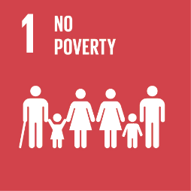
SDG Goal 1: End poverty in all its forms everywhere
The urban and rural poor routinely face unacceptably high risks of exposure to mercury because of their occupations (e.g. mercury mining, artisanal and small-scale gold mining, waste management, recycling), living conditions (proximity to dumpsites and incinerators) and lack of knowledge of potential health impacts of exposure to mercury. At the same time, ecosystems that provide essential resources for the survival of the rural poor, are affected by mercury contamination. UNDP-supported interventions assist partners in introducing alternatives, best practices and techniques to minimize the use and release of mercury, and also address the underlying socio-economic challenges that are at the core of existing practices that use mercury.

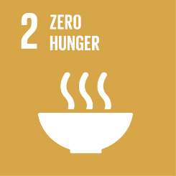
SDG Goal 2: End hunger, achieve food security and improved nutrition and promote sustainable agriculture
One of the main sources for exposure to mercury is through consumption of mercury-contaminated fish and shellfish. The consumption of fish containing high levels of mercury, in particular those high on the food chain as mercury bioaccumulates, can have serious health consequences (see SDG 3). This causes health concerns, in particular for pregnant women, the child in utero and young children, as well as for poor communities relying on subsistence fishing. UNDP helps countries decrease the use of mercury and its release into the environment from various sectors, indirectly halting and reducing the build-up of mercury in the food chain.
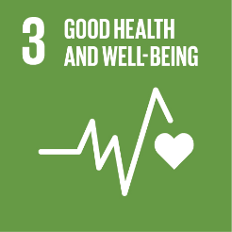
SDG Goal 3: Ensure healthy lives and promote well-being for all at all ages
Mercury is toxic to human health, posing a particular threat to the development of the child in utero and early in life. Human exposure occurs mainly by inhaling elemental mercury vapors during industrial processes and by consuming contaminated fish and shellfish, and can lead to mercury poisoning. Mercury exists in various forms: elemental; inorganic; and organic, which all have different toxic effects, including on the nervous, digestive and immune systems, and on lungs, kidneys, skin and eyes. UNDP supports governments, the private sector and other partners, to reduce or preferably phase-out the use of mercury and mercury-containing products, and minimize its releases, to ultimately protect human and environmental health.

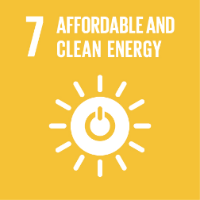
SDG Goal 7: Ensure access to affordable, reliable, sustainable and modern energy for all.
Coal burning, and to a lesser extent the use of other fossil fuels to generate energy, is the second most significant anthropogenic source of mercury emissions into the atmosphere. Use of air pollution controls and more stringent regulations, combined with improved combustion efficiency, can offset most of the mercury releases associated with the increase in coal use, particularly in Asia and South America. However, reductions in current mercury releases will only be achieved after a shift to cleaner and more sustainable energy sources and the introduction of more efficient technologies and products (e.g. mercury-free energy-efficient lighting). UNDP supports countries in strengthening their regulatory frameworks, revising outdated industrial processes and technologies to reduce releases and increase efficiency and, most importantly, in adopting clean energy solutions.

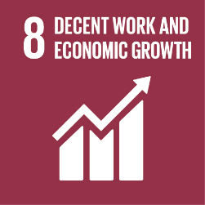
SDG Goal 8: Decent work and economic growth
Exposure to mercury can occur through the inhalation of mercury vapors. Such exposure is most likely to happen in the workplace. Among the most dangerous professions and livelihoods in terms of mercury exposure are artisanal and small-scale gold mining, waste handling and recycling, mercury refining, and health and dental care. Phasing-out the production and use of products and processes which use mercury is the main way to reduce worker exposure. We assist governments and various sectors introduce mercury-free products and processes, while also supporting the development of workplace safety standards and procedures, introducing personal protective measures, and addressing the underlying socio-economic causes that led to the use of mercury and products containing mercury.

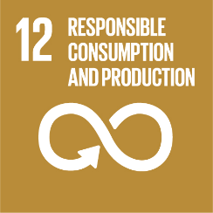
SDG Goal 12: Ensure sustainable consumption and production patterns
Sustainable consumption and production aims at “doing more with less,” increasing net welfare gains from economic activities by reducing resource use, degradation and pollution, while increasing the quality of life. An important aspect of our work is the reduction of mercury pollution and mercury-containing wastes by introducing alternative products, processes and technologies that are mercury-free, cost-effective and in line with best available technology guidelines. Such interventions are aligned with those that increase resource efficiency, use clean and renewable energy, and reduce waste generation, all of which have important mercury reduction co-benefits.

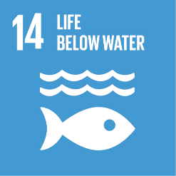
SDG Goal 14: Conserve and sustainably use the oceans, seas and marine resources for sustainable development
Over three billion people depend on marine and coastal biodiversity for their livelihoods, which are being threatened by marine pollution reaching alarming levels. Mercury levels in certain types of fish (e.g. bluefin tuna, swordfish) have become so high that some Governments advise against consumption or have introduced import bans. UNDP helps countries decrease the use and release of mercury from various land-based activities, prevent mercury from entering water sources, and reduce the build-up of mercury in the food chain.

Annex II
Activities of the United Nations Environment Programme on Mercury
The Chemicals and Health Branch, Economy division of the United Nations Environment Programme is delivering mercury-related activities both as a project under the Chemicals and Waste Subprogramme and in their support to GEF activities of the Chemicals and Waste Portfolio. The following are updated mercury-related activities of the United Nations Environment Progamme.
GEF activities
With the support of the GEF, UN Environment is supporting countries in their Minamata Initial Assessments and National Action Plans for Artisanal and Small-Scale Gold Mining. To date, UN Environment is implementing MIA projects in 62 countries and NAP projects in 24 countries.

Since COP1, new MIA projects have been developed in Belize, Kyrgyzstan, Marshall Islands, Micronesia, Niue and a new NAP developed in Kyrgyzstan.

MIAs have been completed in 10 countries and the reports are being reviewed ahead of posting on the Minamata Secretariat website. In addition, UN environment is analyzing data from the inventory reports in view of identifying trend and priorities for future projects.

The global component of the NAP project has organized regional meetings as well as developed tools and methodologies to assist countries in their NAP development.

UN Environment is the lead agency of the GEF Programme entitled Global Opportunities for the Long-term Development of the Artisanal and Small-Scale Gold Mining sector – GEF-GOLD. In this Programme, UN Environment is working with Conservation International, UNDP, UNIDO in Burkina Faso, Colombia, Guyana, Indonesia, Kenya, Mongolia, the Philippines and Peru to assist the sector in reducing and where feasible eliminate mercury use in the sector. The Programme will focus on formalization, access to finance and international markets, technology transfer and knowledge management & communication. All the projects under the Programme have been developed and approved by the GEF. The programme launch is planned for the beginning of 2019.

UN Environment is the lead agency for the multifocal GEF Programme entitled Mediterranean Sea Programme (MedProgramme): Enhancing Environmental Security. In this Programme, UN Environment will work with EBRD in the region to address land-based pollution sources. Mercury pollution from operating and closed chlor-alkali industries will be one of the focus. The projects under this Programme are under development with a planned submission in early 2019.

In GEF6, UN Environment has increased its support to member states on the mercury issue with a total of 42mil$ of new projects approved in the cycle. With the entry into force of the Convention and the priorities identified during the MIA projects, UN Environment will continue to implement its current portfolio and develop new initiative in the next GEF replenishment.
Global Mercury Assessment 2018
Global Mercury Assessment 2018, an update of the 2013 report as requested by the Governing Council of the United Nations Environment Programme, will be launched at the 2nd meeting of the Conference of the Parties to the Minamata Convention in November 2018. The main focus is on updating the global emissions and releases inventory components, using 2015 data, especially for sectors of relevance for the Minamata Convention. The assessment is expanded with respect to quantification of releases of mercury to the aquatic environment, and also includes an overview and assessment of mercury levels in humans and biota. The work is carried out in close cooperation and with the support of the Arctic Monitoring and Assessment Programme secretariat. The Global Mercury Partnership is contributing to the development of estimates of emissions and releases of mercury to the environment, to updating the information on environmental levels and trends in air and to the development of the new sections on humans and biota. A draft technical background report and a draft summary report were circulated for comment by all interested stakeholders in August 2017 and May 2018 respectively, which provided governments with the opportunity to contribute, particularly in relation to the data relevant to emission and releases from their territory.
Mercury Inventory Toolkit
United Nations Environment Programme has developed a Toolkit for Identification and Quantification of Mercury Releases, which is used to develop a national mercury inventory in Minamata Convention Initial Assessments. The Toolkit was updated in 2017 to allow the inclusion of information about existing mercury controls and managements practices in the emissions and releases estimations in simplified spreadsheet calculation.
Mercury Supply, Trade, and Demand Report 2017
In 2006 UNEP published the Summary of Supply, Trade, and Demand Information on Mercury. The report was well-received and helped countries better understand the sources, trade flows, and end uses of mercury. Since the report was published, there have been major changes in the mercury market, and trade pathways have significantly changed, particularly following adoption on controls of the movement of mercury from previously significant mercury exporters. The new report provides updated picture of the global mercury supply, trade and demand, including updates on new mercury mining, changes in use patterns, and the challenges faced in quantifying mercury trade using existing data sources.
GEF related support activities
The Chemicals and Health Branch is providing support to countries undertaking Minamata Initial Assessments. This support is provided through the MIA global component. A checklist was developed to assess the completeness and accuracy of data and information obtained from the MIAs. Reviews of final MIA reports are currently being undertaking using this checklist. Standard data and information emanating from these reviews will provide regional trends and information on sources of mercury releases and implementation needs of countries.
GEF NAP projects implemented by UN Environment include a global component carried out by the Chemicals and Health Branch. The objective of the global component is to provide targeted technical assistance by leveraging the Global Mercury Partnership and to ensure information and experience are shared across all UN Environment NAP countries. The global component is currently working with 24 NAP countries to assist with accessing ASGM experts, planning development of NAP components, estimating ASGM baselines, and reviewing NAP national overviews and draft NAPs. The global component has developed several guidance materials on topics such as baseline estimates, formalization, mercury-free processing techniques, and mercury trade. Regional trainings were held ensure NAP countries are able to use and benefit from guidance materials and share experiences in their actions to address mercury use in ASGM. The NAP global component will also integrate with the GEF GOLD programme’s knowledge management component to ensure resources and expertise are made available in a systematic and technically rigorous manner. In addition, the Chemicals and Health Branch, in cooperation with Global Mercury Partnership, will provide targeted technical assistance to the global knowledge management project of the GEF GOLD programme. The objective is to facilitate information sharing among child projects and with the broader community of ASGM stakeholders and curate knowledge generated in the programme.
Mercury monitoring
Although guidelines, standard operating procedures (SOPs) and/or protocols have been developed by governmental or academic institutions, the existing approach to mercury monitoring does not provide sufficient and specific guidance to countries in order to establish a monitoring system at a global level. In this regard, UN Environment, in collaboration with partners, is implementing a GEF project that aimed at filling in some of those gaps while providing elements that need to be considered to ensure reliable and comparable data on human exposure to and environmental concentrations of mercury, as well as strengthen the capacity for mercury analyses in human and the environment.
Building on the existing experiences in mercury monitoring, the project has created the scientific bases for monitoring of mercury in air and in humans at global, regional and local levels. A harmonized approach to mercury monitoring, including standards operation procedures for sampling and analysis of mercury in environmental media (air) and human biological material (human scalp hair, cord blood, and urine), and survey protocols have been developed to enable collecting of reliable and comparable data. The applicability of the proposed techniques has been pilot tested for human biomonitoring (HBM) and air globally.
UN Environment is also developing and populating a global databank on laboratories analysing mercury, which serves as a repository of laboratories, aims to assist stakeholders and countries on technical-scientific issues related to monitoring, inventories, and Internationals analytical capacities, to access the databank use the following link: http://informea.pops.int/HgPOPsLabs/index.html. The databank has served as the based for first round of the Global interlaboratory assessment of laboratories analysing mercury.
More information can be found in: https://www.unenvironment.org/explore-topics/chemicals-waste/what-we-do/mercury/mercury-monitoring, and UNEP/MC/COP.1/INF.15.
Mercury waste
The International Environmental Technology Centre of the United Nations Environment Programme has been implementing a project on environmentally sound management of mercury waste funded by the Government of Japan since 2015. The project focuses on assisting Parties to the Minamata Convention and other countries to develop and implement environmentally sound management of mercury waste based on their national practices.

The project is composed of 5 components:
- Regional workshop on the environmentally sound management of mercury waste in Asia;
- Regional study on mercury waste in the Member States of Association of Southeast Asian Nations (ASEAN);
- Global Mercury Waste Assessment;
- Online training module of mercury waste management; and
- Investigation for open burning of mercury waste.
At the first Conference of the Parties to the Minamata Convention, the International Environmental Technology Centre launched the Global Mercury Waste Assessment as the first ever global report on mercury waste. The Global Mercury Waste Assessment identified that many countries still face the fundamental challenge of waste management itself. They manage mercury waste as part of municipal or industrial waste and dispose of it as mixed waste in landfills or at open dumping site or by open burning. Some countries have no mechanism for the separate collection of wastes, except for recyclables, and some have no formal waste collection system, no formal disposal site, and little or no awareness of waste management. Other countries identify mercury waste in their regulatory frameworks, but do not have the capacity to implement the mercury provisions.

Annex III
Input by the United Nations Industrial Development Organization for the second meeting of the Conference of the Parties to the Minamata Convention on Mercury
UNIDO’s approach
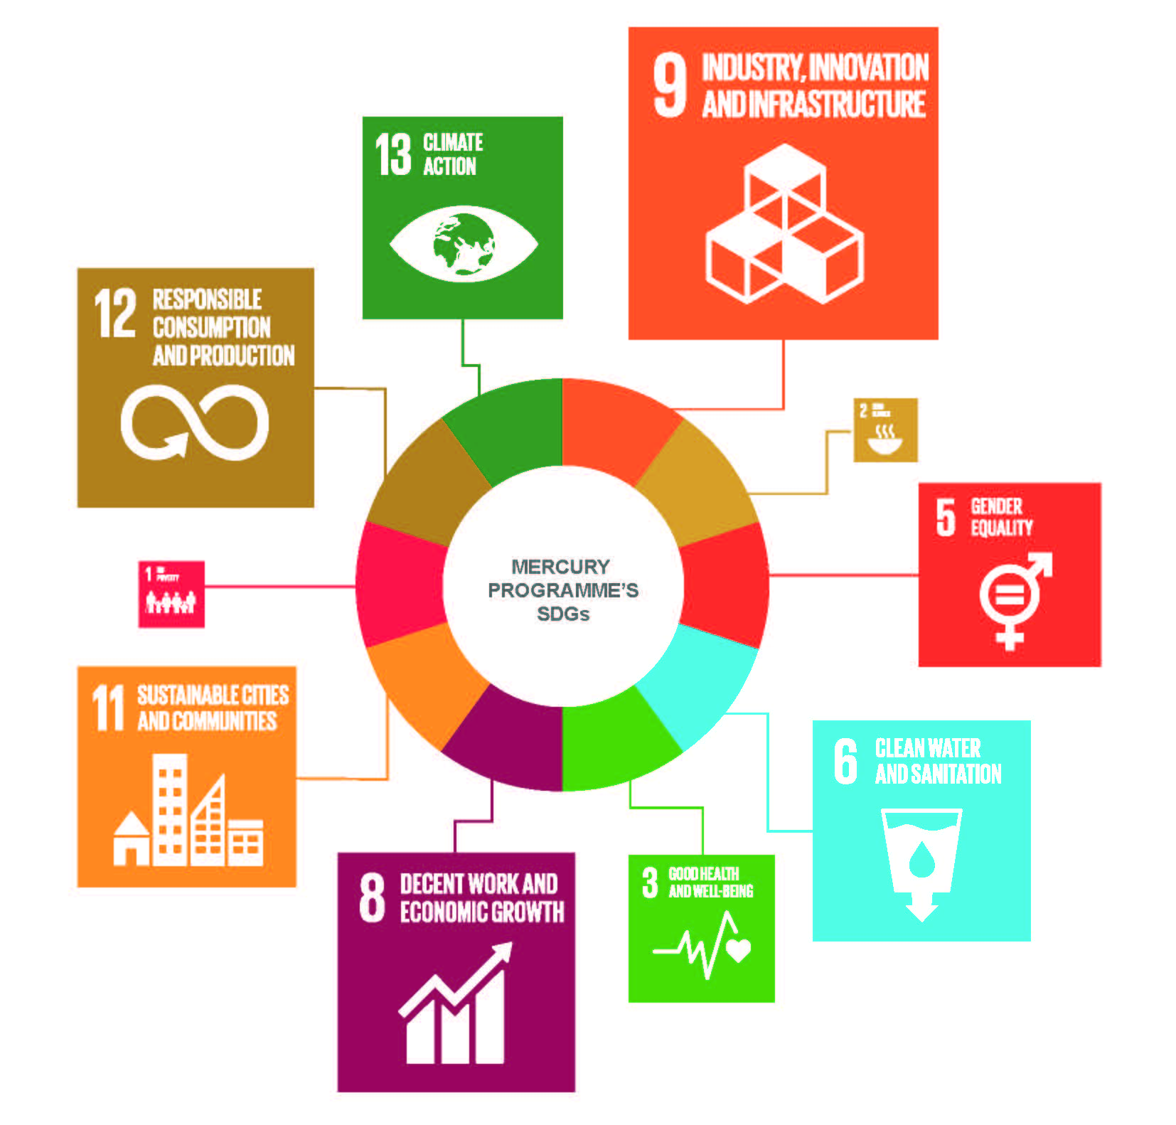
UNIDO is a specialized agency of the United Nations with the mandate of promoting and accelerating inclusive and sustainable industrial development (ISID) in developing countries and economies in transition. UNIDO’s mission contributes strongly to Sustainable Development Goal 9 which calls to “Build resilient infrastructure, promote inclusive and sustainable industrialization and foster innovation”, but is also instrumental to the achievement of all the other goals.
The Mercury Programme at UNIDO benefits from the Organization’s extensive experience in assisting developing countries to comply with multilateral environmental agreements, such as the Montreal Protocol on Substances that Deplete the Ozone Layer and Stockholm Convention on Persistent Organic Pollutants. In the last years, UNIDO has developed a substantial project portfolio in order to assist countries to fulfill their obligations under the Minamata Convention. UNIDO’s experience in mercury started with the artisanal and small scale gold mining (ASGM) sector more than 20 years ago. In the recent years, the programme expanded to other industrial areas including mercury waste management and mercury in processes (chlor alkali and vinyl chloride monomer production sectors). In addition, UNIDO has a strong international network of partners consisting of private sector entities, academia, research institutions, other UN and donor agencies, NGOs and governments. Moreover, UNIDO has field representation in more than 47 countries. Together with its partners, UNIDO’s Mercury Programme is leading and facilitating the introduction of mercury free technologies and policy reform to minimize the use and discharges of mercury. It promotes Best Available Technologies (BAT) and Best Environmental Practices (BEP) through awareness raising, capacity building, legislation strengthening and technology transfer.
Projects
In accordance with UNIDO’s commitment to support governments in fulfilling their legal obligations under the Minamata Convention on Mercury, the Organization has initiated, since the end of the GEF-5 replenishment period, Minmata Initial Assessments (MIA) projects and National Action Plans (NAP) projects on mercury in the ASGM sector. In addition, the Mercury Programme portfolio includes large scale projects on ASGM, vinyl chloride monomer production, mercury contamination in freshwater and marine aquatic environments, and mercury waste management. More details on the projects completed and currently under implementation by UNIDO can be found under www.unido.org/mercury

- Minamata Initial Assessments (MIA) and other support for ratification and early implementation
- UNIDO is assisting the following 23 countries in the implementation of their MIA projects: Armenia, Benin, Burkina Faso, Cabo Verde, Chad, China, Colombia, Comoros, Guatemala, Guinea, Mali, Mongolia, Nepal, Niger, Nigeria, Sao Tome and Principe, Senegal, Sri Lanka, Sudan, Togo, Turkey, Vietnam and Yemen. The goal of the MIA enabling activities is to complete pre- or post-ratification activities to enable policy and decision making and to prioritize areas for future interventions through a national mercury inventory.

With the support of Switzerland, UNIDO implements a global programme on promoting ratification and early implementation of the Minamata Convention since 2016. This programme offers needs based assistance to countries and (sub) regions. Up to now eight countries (Armenia, Bangladesh, Costa Rica, Guatemala, Malawi, Philippines, Tunisia and Vietnam) and two Sub regions (Caribbean and ECOWAS) participate in this program. The thematic areas range from awareness rising on the ratification dossier, to the domestication of international chemicals waste management Conventions and extends to sustainable management of mercury containing products and wastes. In addition, four specific regional events were organized.

- Artisanal and Small-Scale Gold Mining (ASGM)
- UNIDO assists governments in the development of the National Action Plans (NAP) by providing the basic and essential information to enable policy and strategic decision making and by assisting the development of strategies and road maps within countries. The projects strengthen the countries’ national capacity to fulfill obligations under the Minamata Convention and promote effective implementation of its provisions. Currently UNIDO is implementing NAP projects in Burkina Faso, Ecuador, Gabon, Ghana, Mozambique, Nigeria and Peru.

- The GEF Global Opportunities for Long Term Development of the ASGM sector (GOLD) project focuses on policy strengthening to support formalization of the sector, facilitating access to financing for miners, capacity building of national specialists on mercury-free technologies and formalization, awareness raising and knowledge management in the ASGM sector. To promote a sustainable business model as a basis for accessing international gold markets for miners, UNIDO has a Memorandum of Understanding (MoU) with Argor-Heraeus S.A., one of the world’s largest refiners of precious metals working together to achieve a sustainable adoption of mercury-free technologies in artisanal and small scale gold mining. UNIDO is implementing one GEF GOLD child project in Burkina Faso, and in collaboration with UN Environment in Mongolia and the Philippines.

- Waste management
- UNIDO offers assistance to countries in the establishment of regulatory framework and national guidelines for environmentally sound management of mercury containing waste as well. Projects focusing on waste management support the development of capacities for the implementation of remediation and stabilization techniques in mercury hot-spot areas through demonstration activities at the pilot scale. This was done in Mongolia in the framework of a recently completed GEF-5 funded project. UNIDO and Nomura Kohsan Co. Ltd. signed a Memorandum of Understanding (MoU) in 2014 to prevent mercury containing wastes entering the environment and ensuring Best Environmental Practices and Best Available Techniques are applied to extract mercury from wastes, and identifying long-term solutions for the storage of mercury.

- In Tunisia, UNIDO is implementing the project entitled “Improve Mercury Management in Tunisia” to review and validate the remediation plan for a former chlor-alkali plant in Kasserine. The goal of the initiative is to reduce negative impacts of mercury contamination to human health and the environment by (a) strengthening the national capacity to manage mercury containing waste and comply with the Minamata Convention; and (b) improving the remediation plan of the company SNCPA through the collection of complementary information during the project. The project started in June 2015 and will be completed in 2018.

- With the support of Swiss and Japanese government, UNIDO organized an expert group meeting on sustainable management of mercury waste in September 2018 in Vienna. More than 70 people actively participated in the meeting to discuss interim disposal, treatment, and final disposal of mercury wastes. Country delegates from Latin America, Africa and Asia were present as well as a variety of private sector representatives to share experiences and challenges in managing the sector. Meeting results will be shared during COP2 in a formal publication from UNIDO.

- Non-Ferrous Metal Smelting
- Since September 2012, national and local capacity is being strengthened in China, enabling the country to effectively manage and reduce mercury emissions from zinc smelting operations in neighboring communities. BAT and BEP for cleaner zinc production have been demonstrated at two pilot sites. The project also established a coordination and monitoring system, and proposed policy reform for mercury management in the zinc smelting sector. The initiative is funded by the GEF and co-financed by the Foreign Economic Cooperation Office (FECO) of Ministry of Environment; Zhuzhou, Shuikoushan and Shangluo (zinc enterprises); Hunan, Shaanxi, and Guizhou provinces; Sino-Norwegian projects; and UNIDO. The project concluded successfully at the end of 2015.

- Vinyl Chloride Monomer Production
- In order to reduce risks to human health and the environment related to the use of mercury in the industrial production of vinyl chloride monomers (VCM) in China, UNIDO developed a large scale project, which is about to be approved by the donor, in collaboration with the Ministry of Environment and Foreign Economic Cooperation Office. In China, VCM is one of the largest mercury consumer sector, accounting for 30% of world’s total mercury consumption. The goals of the initiative are (a) to strengthen institutional, regulatory, and enforcement capacity in VCM production to enable the country to fulfill obligations under the Minamata Convention related to the sector; (b) promote technology transfer and investment for the widespread application of BAT/BEP; (c) promote the recovery of mercury from mercury-containing waste in VCM production process; (d) identify, assess and prioritize contaminated sites associated with VCM production; and (e) disseminate information and raise awareness among stakeholders. The planned project duration will be five years. Once completed the project is extended to have removed 360 tons of mercury from the environment.
Minamata beyond COP2
Most of the identified issues relating to mercury are industrial by nature, which reinforces the increasing and significant role that UNIDO has and will have in the coming years in assisting countries to reduce, and where feasible, eliminate the use of mercury, as well as its emissions and releases to the environment as a whole. UNIDO will continue to support governments and engage the private sector in fulfilling their legal obligations under the Minamata Convention.
The Minamata Convention Initial Assessment that results from the enabling activities currently implemented by UNIDO will provide a basis for prioritization and development of sectoral intervention plans to be supported by future projects. In the context of the National Action Plan enabling activities, a road map for the reduction of mercury in the ASGM sector, including needed interventions and potential funding sources, will serve as the basis for the development of impactful projects supporting the implementation of these National Action Plans. UNIDO wants to strategically focus on developing the entrepreneurs and small scale industries active in ASGM towards improving their business models through formalization and support their access to international markets by (i) eliminating the use of mercury, (ii) the improving working conditions and (iii) eliminating the worst forms of child labor. UNIDO’s Mercury Programme seeks to find a more integrated approach in the future through the implementation of thematic programmes where advantage can be taken from the occurring synergies. Aside from the topic areas mentioned earlier, UNIDO is also actively expanding its services to provide expertise in the chlor alkali, cement production and consumer products sectors. Based on its experience and expertise, working with a team of currently 9 people, the UNIDO Mercury Programme has a comparative advantage under the framework of the Minamata Convention.
In conclusion, focus will be placed on setting national objectives and targets, complementing existing programmes, exploring innovative market-based approaches, promoting policy reform, enhancing awareness, and promoting intervention on the ground to secure mercury emission reduction globally through technology transfer.
Contact:
mercury@unido.org
www.unido.org/mercury

Annex IV
Activities on mercury of the United Nations Institute for Training and Research – since COP1 (September 2017)

UNITAR has supported countries in the development of their Minamata Initial Assessment reports and National Action Plans, working with GEF implementing agencies. These are: MIAs in Benin, Burkina Faso, Comoros, Guinea, Mali, Niger, Nigeria, Senegal, Togo and Yemen (UNIDO); MIAs in Bangladesh, Ghana, Guinea-Bissau, Mauritania, Mozambique and Samoa (UNDP); and joint MIAs and NAPs in the Democratic Republic of Congo, Eritrea and Sierra Leone (UN Environment). This is in addition to more specific support for inventory components of several MIAs (UN Environment).

In addition, UNITAR finalized most activities for its Minamata Ratification project, funded by the Government of Switzerland. This project supported 22 countries in their ratification processes. Fifteen of these countries have ratified the Convention, with two having done so in the period since COP1.

UNITAR ran a guided version of its online MercuryLearn training course on the UN Environment toolkit for inventories. This course included for than 50 participants, with 47 gaining certificates of completion (either for level 1, or for the entire course, being level 1 and 2). The self-guided course remains available on the UNITAR website (http://mercurylearn.unitar.org/), and can be taken at any time.

UNITAR is currently performing an update of the UN Environment toolkit for mercury inventories. Waste, products and industrial gold production are among the prioritised issues. The project is planned to be finalised by the end of 2018, funded by the Nordic Council of Ministers and the Danish Environmental Protection Agency.

UNITAR also hosts the UN Environment-UNITAR Mercury Platform:
(http://mercury.unitar.org/site/home). This platform serves to provide information on supported projects, and provide access to experts and awareness-raising materials. This is updated throughout the year.

Furthermore, UNITAR hosts a chemicals and waste platform (funded by the Government of Switzerland: http://chemicalsandwaste.org/). This highlights synergies among the Basel, Rotterdam and Stockholm, and Minamata Conventions, seeking to learn lessons from past activities; particularly relevant for the implementation of the newest Convention, Minamata.

* UNEP/MC/COP.2/1.
In some cases, the management of mercury is a small component of a larger project focusing on reducing/phasing out other chemicals. For these medical waste projects, a 20% mercury component was applied to projects.
PPG = project preparation grant
Funded by Sweden as part of the Poverty Environment Initiative (PEI).

