UNITED  NATIONS |  | MC
 |  | UNEP/MC/COP.2/INF/17
 | United Nations  Environment  Programme | Distr.: General  5 November 2018  English only
Conference of the Parties to the
Minamata Convention on Mercury
Second meeting
Geneva, 19–23 November 2018
Item 5 (h) of the provisional agenda*
Matters for consideration or action by the Conference
of the Parties: cooperation with the World Health
Organization and the International Labour Organization
Addressing health aspects in the context of developing national action plans under the Minamata Convention on Mercury
Note by the secretariat
The annex to the present note sets out a document developed by the World Health Organization on addressing health aspects in the context of developing national action plans relating to artisanal and small-scale gold mining under the Minamata Convention on Mercury. The document is presented as received, without formal editing.

Annex
Addressing health aspects in the context of developing national action plans under the Minamata Convention on Mercury

Addressing health aspects in the context of developing National Action Plans under the Minamata Convention on Mercury

WHO WORKING DOCUMENT

22 October 2018

© World Health Organization 2018

The present working document provides a WHO guidance to support Member States in ensuring the health aspects are appropriately taken into consideration as part of national action planning processes focused on ASGM.
This guidance document has been developed as part of a WHO technical series on ASGM and health and specifically addresses how and where health considerations should be considered in the context of National Action Planning (NAP) processes related to ASGM, in particular as required under the Minamata Convention on Mercury. It addresses the provision of Paragraph 3 (a) of article 7 of the Minamata Convention on Mercury stating that each party that has notified the secretariat that artisanal and small-scale gold mining and processing in its territory are more than insignificant shall develop and implement a national action plan in accordance with Annex C to the Convention. It addresses also the coverage of health in the wider NAP development process, for example when establishing national coordination mechanisms, conducting stakeholder engagement activities, developing a national overview of the ASGM sector, etc. It also provides a suggested orientation to support the development of the public health strategy component of the NAP. The latter is specifically focused on addressing content required under item (h) of Annex C of the Minamata Convention. However, as it also addresses awareness raising activities including in the context of engagement and identification of vulnerable groups, the document may also aid in the development of content required under items (i) and (j).
The current version of the document incorporates feedback WHO has received after a period of consultation from selected Member States as well as some UN sister agencies supporting ASGM and national action planning activities so as to ensure that this guidance adequately addresses country needs and processes.
Based on the current country work aiming at supporting selected Member States in developing the health component of the NAPs and the related public health strategy, this guidance document will in future benefit from practical experience.
It should be noted that this document is subject to editing for formal publication as a WHO document.

Contents

1. Addressing health during the wider process of developing a NAP 6
1.1 Engaging health actors in the coordination and development of the NAP 7
1.2 Addressing health issues as part of the development of the national overview of the ASGM sector 8
1.3 Ensuring health is considered more broadly during the formulation of the NAP 9
1.4 Clarifying the health sector’s role in supporting the implementation (and evaluation) of the NAP 9
2. An orientation for the public health strategy 11
2.1 Aligning the strategy with a clear public health objective 11
2.2 Defining specific contributions from the health sector 13
2.3 Suggested areas of activity and focus 13
2.4 Implementation of the public health strategy: key considerations and next steps 14
Annex 1 Data types/sources and potential uses for informing the public health response to ASGM 16

Introduction
This document provides an approach to addressing health issues as part of the development of a National Action Plans (NAP) to reduce, and where feasible, eliminate mercury use as required under the Minamata Convention on Mercury.
Under the Convention, NAPs are a requirement for those Parties that determine that “artisanal and small-scale gold mining and processing in its territory is more than insignificant.” A NAP must include public health strategies on the exposure of artisanal and small scale gold miners and their communities to mercury. Such strategies are expected to include, among other things, the gathering of health data, training of health care workers and awareness-raising through health facilities.
While it is understood that the public health strategy component of the NAP will be developed and implemented under the authority and direction of the relevant national health authority, other components of the NAP will likely be developed under the leadership of national authorities responsible for environment (e.g. authorities responsible for the implementation of the international chemicals conventions including the Minamata Convention) and/or mining. Good intersectoral engagement and coordination will thus be necessary for ensuring alignment and coherence between these different NAP elements. Indeed, each component will also need coordination within them.
The present document has been developed as part of a WHO technical series on ASGM and health and specifically addresses how and where health aspects should be considered during the process of developing a NAP. A WHO document is available providing an overview of health issues in ASGM, with particular focus on environmental and occupational issues as well as draft protocol for conducting a rapid health assessment of health issues in the ASGM context. More work is underway for providing key training materials for health care providers.
Primary audiences include government officials in health ministries as well as in ministries from other sectors (e.g. environment, mining, labour) that would be involved in the process to develop and implement the NAP. Other audiences include development partners (e.g. UN agencies and international organizations), researchers, non-government organizations, and other actors that would also be engaged in this process.
The document addresses coverage of health in the wider NAP development process, for example when establishing national coordination mechanisms, conducting stakeholder engagement activities, developing a national overview of the ASGM sector. It also provides a suggested orientation to aid in the development of the public health strategy component of the NAP. The latter is specifically focused on addressing content required under item (h) of Annex C of the Minamata Convention. However, as it also addresses awareness raising activities including in the context of engagement and identification of vulnerable groups, the document may also aid in the development of content required under items (i) and (j) of the Convention.
Where relevant, specific references are made to the guidance “Developing a National Action Plan to Reduce, and Where Feasible, Eliminate Mercury Use in Artisanal and Small-Scale Gold mining” developed by the UNEP Global Mercury Partnership ASGM Partnership Area, as this is understood to be the primary reference guide being used and promoted for this purpose. Additional references, for example to other WHO materials addressing/describing health issues related to ASGM, are also provided throughout the text as relevant.
The NAP process is understood to be a “national” process, to be undertaken with a cross-government approach. Therefore, the document has been developed from this perspective. It has also been developed with the understanding that countries will include health aspects in their NAPs in ways that are most suited to their particular needs, priorities and context.
In addition, while the Convention (and therefore also the NAP process) has a specific focus on mercury exposure, there are a number of other hazards associated with ASGM that can be detrimental to health. The public health orientation provided in this document addresses mercury exposure, but also allows for a wider approach and framing of ASGM-related health issues.
Finally, while primarily intended to facilitate coverage of health in the NAP process, this document may also be of interest to other countries seeking to develop public health responses to ASGM but who are not subject to the NAP requirement.

1. Addressing health during the wider process of developing a NAP
This section provides an overview of how and where health considerations should be taken into account as part of the wider process of developing or articulating a National Action Plan. Suggested content for the public health component of the NAP is addressed in Part 2.
The UNEP Global Mercury Partnership ASGM Partnership Area guidance (2015) suggests that NAPs be developed through a process involving six steps as shown in Fig. 1. The first step involves the establishment of a coordination mechanism to ensure appropriate organization of the NAP and to facilitate engagement with relevant stakeholders throughout the process. In the second step, a national overview and profile of the ASGM sector is developed. In steps 3 and 4 NAP goals and objectives are set, and schedule for implementation defined. An evaluation process is established in step 5. And in 6 - the final step - the NAP is endorsed and submitted to the Minamata Convention Secretariat.
From a health perspective, it will be important to ensure that health actors are appropriately engaged in planning and coordination efforts, health information is duly considered as part of the review of the ASGM sector, and that roles and responsibilities of the health sector in achieving targets, aims and objectives set in the NAP are clear. Key areas where health aspects should be considered in the NAP development process are shown in Fig 1 and addressed in the sections that follow.
Fig.1 Coverage of health aspects in relation to the process recommended for developing a NAP
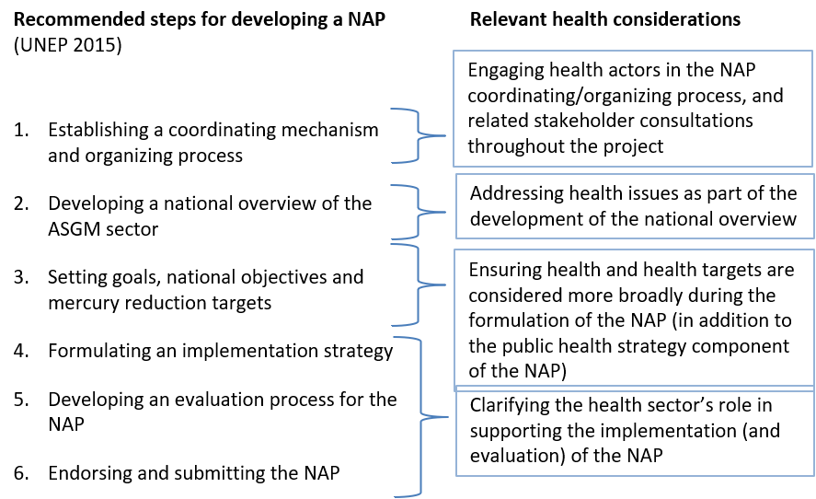

1.1 Engaging health actors in the coordination and development of the NAP
Due to the multifaceted nature of ASGM, a multisectoral and multidisciplinary approach will be needed to support the development of the NAP.
A NAP Coordination Mechanism may be established to facilitate coordination and engagement between different sector ministries providing input to the NAP. In this regard, a representative of the national health authority (e.g. health ministry or other official health agency) would participate formally in this coordination mechanism so as to ensure overall health representation at this level.
In addition to the above, other stakeholder engagement consultation activities may be conducted to inform the development of the NAP, for example to solicit information about ASGM practices and/or associated environment and health concerns.

The level (or degree) to which health actors will be engaged in this process, particularly outside of the formal coordination process, may vary depending on the context and need for health inputs. An overview of potential categories (or types) of health actors and their potential contribution to the NAP development process is provided in Table 1.
Table 1 Health inputs that can inform the NAP development process
Type of health actor | Potential contribution(s)/inputs to the NAP process
Government Official from the Ministry of Health or official health agency | - Ensure appropriate health ministry representation in the NAP development and coordination process  - Lead development of the public health strategy component of the NAP  - Facilitate alignment of NAP related health priorities with wider health and development priorities
Regional or District Health Officer | - Information on ASGM-related health concerns, impacts or outcomes in a given regional context and on available capacities and structures in place to address them
Local health service providers (e.g. nurses, medical doctors, community health workers, including midwives) | - Knowledge about health issues affecting ASGM miners and their communities (related to use of mercury in mining and other related health outcomes due to mining practices)  - Insights about how to reach/engage with populations considered most vulnerable to ASGM-related exposures (e.g. women and children)  - Information on ASGM-related health impacts in the ASGM community, and needs on capacities and structures
Public Health Researcher/Academic | - Information about ongoing or past research initiatives of relevance  - May be able to support the gathering of health data, for example as part of the development of the national overview and baseline of the ASGM sector that is required under the NAP
Representative from a health development agency (e.g. UN agency, international and bilateral organizations) | - Information on relevant health programmes or activities and related opportunities for alignment of efforts
Representative from a health focused non-governmental organization working with ASGM communities | - Insights and knowledge about health issues and work situations affecting ASGM miners and their communities
Other “health” figures in the ASGM community, such as traditional healers | - Knowledge about health issues affecting ASGM miners and their communities  - Knowledge about health seeking behaviour in ASGM communities  - Insights about how to reach/engage with populations considered most vulnerable to ASGM-related exposures (e.g. women and children)
Health specialists (e.g. in toxicology, occupational medicine, infectious diseases) | - Specialist input and advice on specific ASGM-related health concerns to be addressed/reflected in the NAP as needed.

Additional considerations vis-à-vis ensuring appropriate health sector engagement in the NAP development process
- Efforts to solicit health inputs to the NAP development process could be facilitated if a specific approach for stakeholder engagement approach (for health) is developed and agreed with the relevant national authority;
- Countries have different models and degrees of decentralization of authority over decision-making and planning for health. Stakeholder engagement and consultation activities may need to take this into account, particularly if the planning and resourcing of public health activities and health services delivery is determined at the regional or sub-regional levels. If ASGM activities are concentrated in a particular region/province, in such contexts, it also may be appropriate to include a representative from the regional or provincial health authority in the NAP Coordination Mechanism;
- There are likely to be many health actors working in the non-governmental and private sector. An example of the latter might include faith based organizations that work outside, but in coordination with government managed health facilities. As the NAP is intended to be a government-led and owned process, perspectives from health actors working in the “public” sector will need to be considered. However, it may also be beneficial to consider soliciting views and perspectives from the health actors working in the “private” sector as well.

1.2 Addressing health issues as part of the development of the national overview of the ASGM sector
Countries are expected to develop their NAPs on the basis of Convention obligations and based on an analysis of their ASGM sector, the product of which is referred to as the national overview. This analysis should include a socio-economic analysis of ASGM, review of ASGM practices (which includes a baseline assessment of mercury use), and an assessment of relevant health and environmental concerns, including also information about provision of basic amenities such as water and sanitation, housing conditions.
In addition to reviewing available literature and existing national policies and regulations applicable to ASGM, in many cases primary data on ASGM practices will need to be gathered, for example through surveys and field visits to ASGM areas. This can provide a helpful opportunity to also gather information about the health status of ASGM communities and their use of health care services, provided that such data collection and analysis is carried out in conformity with relevant national regulations and requirements (See below additional considerations related to the collection and use of health data).
In addition to the above, other information gathered as part of the development of the national overview, even if not specifically focused on health, can also be used to identify relevant health concerns. For example, information about the socio-economic characteristics of ASGM miners can provide information about other important environmental or social determinants of health, e.g. if they have access to basic social services, can access training or new tools, and/ or reside in potentially precarious housing conditions. For more information about ways in which data gathered to inform the development of the national overview of the ASGM sector can be used for health purposes, see Annex 1.
The national overview can also be helpful in informing the development of the public health strategy. For example, information on mercury use in ASGM can be used to prioritize locations (or communities) where conducting awareness raising and health promotion activities should be conducted or where further data collection and analysis of health impacts may be warranted.
Given the potential utility of information likely to be used for the national overview, opportunities to include health-relevant data should be considered as part of the planning and design of data collection protocols and tools. Consideration should also be given to modalities and means through which data can be shared for use in conducting analyses for other parts of the NAP, as appropriate.

Additional considerations related to the gathering of health data as part of the development of the national overview of the ASGM sector
- Careful consideration should be given as to the processes, methods, and formats (e.g. large collective meetings, small focus group discussions) used to support information collection activities in ASGM communities and with potentially vulnerable populations particularly if such information includes data on health. Many countries have regulations and requirements regarding the collection and use of primary health data, including national ethical approval for research with human subjects. This will be particularly relevant if there is any intention to conduct human bio-monitoring, for example as part of the mercury base-lining activities. Early engagement of health actors (e.g. with experience in conducting public health research) in the planning and design of primary data collection activities will help clarify whether such regulations apply.
- The inclusion of local health authorities, e.g. municipal or equivalent health officers, in the primary data collection may facilitate engagement with primary health care providers in ASGM areas and may help to ensure that the gathering (and handling) of health data from ASGM communities is carried out in accordance with relevant health regulations. It may also help to ensure that if health problems are identified (e.g. mercury intoxication is suspected) appropriate follow up is provided through the health system.

1.3 Ensuring health is considered more broadly during the formulation of the NAP
Once the current ASGM situation (or context) has been assessed, goals, targets and objectives will be set, taking into account requirements set in the Convention and Annex C.
Many measures that will be included in the NAP, for example to reduce burning of amalgam in residential areas, facilitate the formalization or regulation of the ASGM sector, will have a positive effect on the health and well-being of ASGM (and nearby) communities. Measures to formalize ASGM for instance can facilitate miner access to health and other social services, if, due to a change in the formality of their employment status, they may become eligible for health insurance, social security, disability insurance.
Applying a “health lens” to the selection of measures for the NAP may also help to identify potential unintended effects of NAP interventions that could negatively impact health. For example, if following a review of regulations applicable to ASGM, a decision is taken to simplify the environmental licencing process –a commonly cited obstacle to the formalization of ASGM – it would be important to consider the impact of this modification from both an environmental and health perspective. While in some instances the environmental footprint of small-scale mining activities may not be considered to be significant (for example as compared with medium or large-scale mining), depending on how and where these activities are carried out, they may have important associated social and human health risks. Environmental and social due diligence conducted during the environmental licensing process is critically important for ensuring that mining activities do not adversely impact on the health and well-being of miners and nearby communities. Similarly, awareness that mining activity is often the primary source of income of ASGM communities mean that closing down mines purely on the basis of health or environmental risks may not be a long-term solution and requires the need to find a balance between facilitating formalization and maintaining a process that ensures that adequate environmental and social safeguards are put in place.

1.4 Clarifying the health sector’s role in supporting the implementation (and evaluation) of the NAP
Once the NAP objectives, goals and targets associated measures have been set, a schedule for implementation needs to be developed. This schedule must be submitted along with the final NAP. The UNEP Global Mercury Partnership ASGM Partnership Area guidance (2015) proposes that this schedule may also include a plan of work, timeline, and budget.
When developing the overall NAP implementation schedule, it will be important to clarify inputs expected from the health sector, not only for the public health component, but also in the context of other activities where health inputs may be relevant. Examples of the latter might include: engagement of health actors in the monitoring and evaluation of NAP implementation; and ensuring inclusion of appropriate health promotion messaging within wider information dissemination and communications activities supported through the NAP. Information on human health impacts of mercury are important and can add significant value to such a national action plan. Monitoring and evaluation against such indicators represents a clear opportunity to showcase progress in implementation.

2. An orientation for the public health strategy
The first section of this document provided an overview of where and how health issues should be considered within the wider process of NAP development. This section focuses on the development of the public health strategy which needs to be included as a specific component of the NAP.
The section begins with a discussion on how to frame the strategy from a public health perspective, and then addresses the need to clarify the scope of work to be supported by the health sector in coordination with efforts supported by others. Suggested areas of focus for the strategy are also provided, including in a model strategic framework provided as an annex to this document.
While the primary focus of this section is on developing public health strategies that take into account requirements set under item (h) of the Minamata Convention, it may also aid in the development of other strategies that should also be included in the NAP in particular strategies to prevent exposure of vulnerable populations and strategies for providing information to ASGM and affected communities as called for under items (i) and (j) of the Convention respectively.

2.1 Aligning the strategy with a clear public health objective
While the NAP will have an overall objective (and focus) on reducing, and where feasible eliminating, mercury use in ASGM (as this is the requirement under the Convention), the overall objective of the public health strategy should be expressed as a health objective. This might be, for example: reduced morbidity and mortality (adverse health outcomes) resulting from exposure to mercury and other health hazards associated with ASGM. Not only will this provide a clear “health” focus for the strategy, it will facilitate alignment of the strategy with other national health objectives (which will be similarly focused on reducing morbidity and mortality).
Fig 2 provides an example of how a results chain for a public health strategy aligned with the above objective might be constructed. Under this model, the underlying hypothesis is that fewer adverse health outcomes will arise if: a) miners adopt safer and more environmentally friendly practices; and b) ASGM-related health issues are taken into account by (and therefore addressed as part of) existing public health programmes and health service delivery packages as relevant.
If miners adopt safer and more environmentally-friendly ASGM practices, those miners and nearby communities well be less exposed to mercury and other ASGM-related health hazards. Fewer adverse health effects will therefore result from ASGM.
If public health programmes and health services delivery packages include a specific orientation to ASGM-related health issues, they will be better able to mitigate the effects (or severity) of ASGM related exposures, which in turn will also reduce morbidity and mortality.
In addition, measures taken to address ASGM-related health issues will be more sustainable if such measures are integrated (or absorbed) into wider and existing health programmes. For example, where ASGM-specific health promoting activities are conducted as part of other routine health promotion activities, such as vaccination campaigns, HIV campaigns.

Fig. 2 A model results chain to inform the development of the public health strategy component of the NAP.
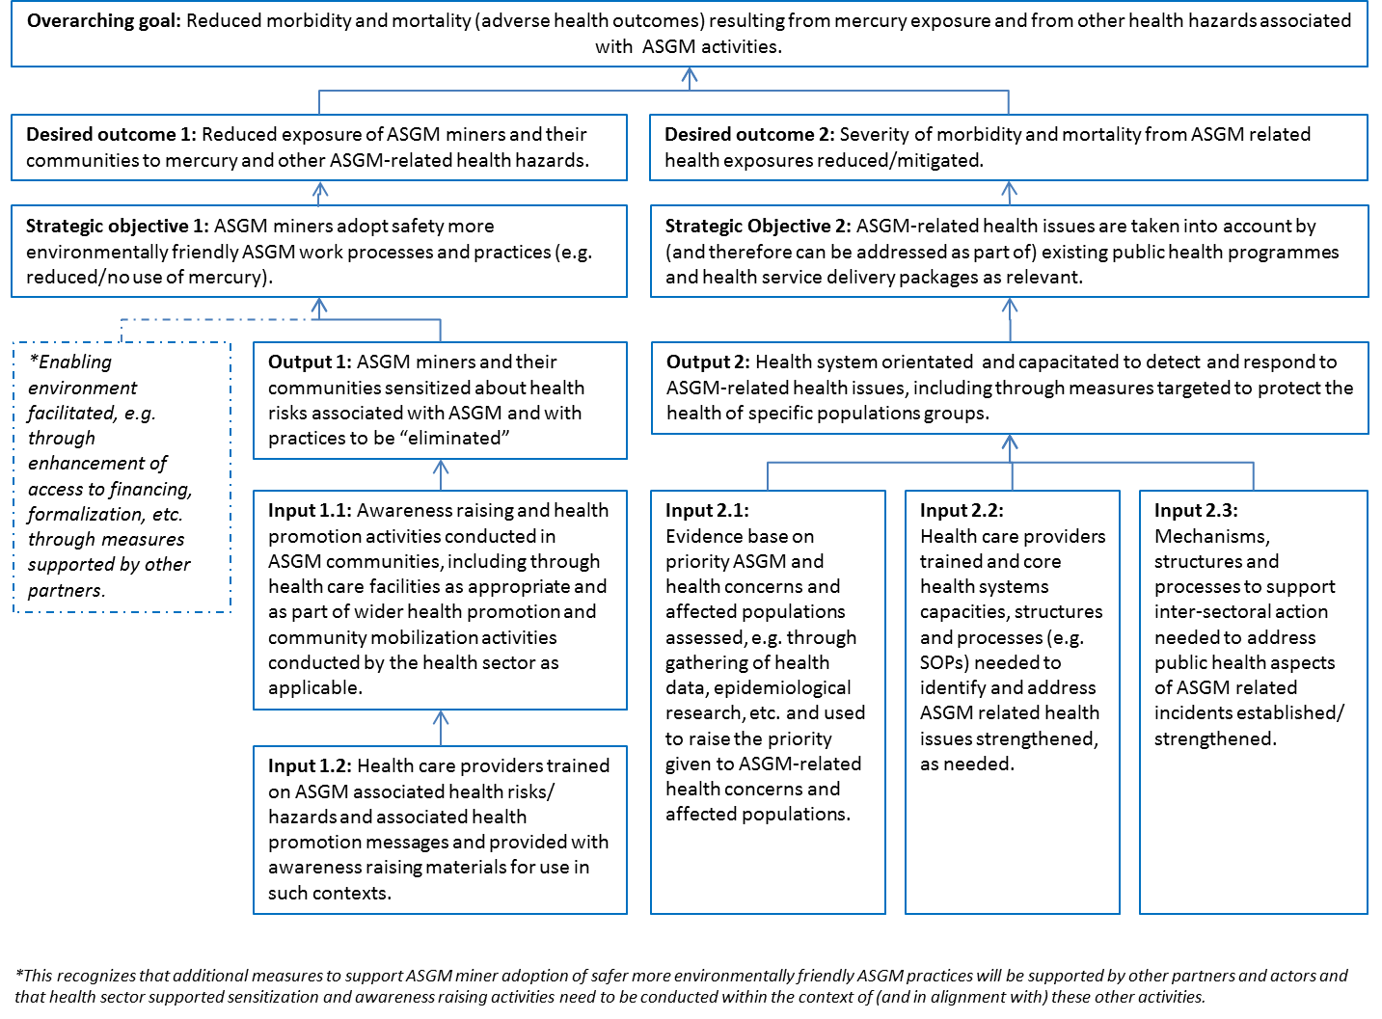

2.2 Defining specific contributions from the health sector
Taking into account the overarching goal and strategic objectives set in the public health strategy, it may be helpful to define a specific set of outputs to be “delivered” by the health sector. Using the example provided in Fig 2, these might be defined around specific interventions (such as in relation to outreach conducted with specific ASGM communities or populations) or as programmatic or service delivery objective.
Some objectives may be reached only with inputs provided from the health sector, while others may need additional inputs from elsewhere. For example, in Fig.2 changing ASGM practices will depend on a variety of factors (e.g. miner access to financing, technological know-how). The specific contribution of the health sector in this regard could be to sensitize miners and associated workers about health risks of ASGM and with practices to be reduced or eliminated under the Convention. Opportunities to ensure health sector engagement in the wider NAP development process have been addressed in sections 1.1 and 1.3 of this document. Such opportunities may also be useful in informing the development of the public health strategy as it will further aid in clarifying roles, responsibilities under the NAP and can help ensure alignment and coherence of efforts.

2.3 Suggested areas of activity and focus
Annex C of the Minamata Convention stipulates that the public health strategy component of the NAP must include, among other things, the gathering of health data, training of health providers; and conduct of awareness raising activities through health facilities.
The model shown in Fig 2 provides an illustrative example of how these “mandatory” activities might be reflected as inputs to a broader strategy aimed at reducing adverse health outcomes from ASGM. For example, health care providers will need to be trained and provided with awareness raising materials if they are to conduct health promotion activities on ASGM in their health clinics and/or as part of wider community engagement activities. Health data will need to be gathered and analysed in order to provide evidence on the health impacts of ASGM and its resulting health burden. The latter will be key for informing the level of priority given to ASGM related health issues, and correspondingly the degree to which ASGM is taken on and addressed through (as part of) existing health programmes. The process of gathering and assessing health data will also reveal if there are important data and/or knowledge gaps that need to be addressed, for example with further research.
In addition to the collection (and assessment) of health data, training of health care providers, and conduct of awareness raising activities, the public health strategy may also include measures that will ensure health systems are appropriately orientated towards this issue.
Key inputs or measures to aid in this “ASGM orientation” process might include:
- Assessing available epidemiological evidence on the health impacts of ASGM so as to facilitate the identification of priority ASGM-health issues to be addressed and relevant population groups affected,
- Assessing existing health systems capacity to determine whether adequate structures, systems and processes are in place (e.g. to support mercury detection and case management, laboratory capacities) and identify what capacity building and training is needed;
- Establishing a mechanism to facilitate health sector engagement and collaboration with other sector ministries and other relevant stakeholder groups around ASGM.

In many countries, ASGM will likely have been going on for some time. The health of miners, associated workers, and their communities may in such cases already be adversely affected. A key objective of the institutional capacity assessment will thus be to assess the relative readiness of the health system to provide health services to these affected populations.
As described earlier in this document, stakeholder engagement activities will be needed to support the overall developing and implementation of the NAP. There may however be a need for other forms of intersectoral engagement and communication on ASGM and health issues that extend beyond the scope of the NAP, for example in the case of coordinating public health responses to ASGM related emergencies or accidents, such as in the context of the International Health Regulations.
While it is understood that the specific orientation and content of the public health strategy will vary across countries depending on the national context and priorities, an example strategic framework for a public health strategy is provided in Table 2. This example builds on the results chain presented earlier and includes additional details about potential supporting activities. Some of the activities described would need to be implemented at a system-wide level and some would need to be orientated to a specific audience or level of the health system. Comments to this effect are also provided.

2.4 Implementation of the public health strategy: key considerations and next steps
Once the NAP and public health component of the NAP are endorsed, the relevant national health authority (or regional health authorities if applicable) will need to develop a detailed implementation plan to support the implementation of this strategy. This plan will need to outline what activities will be carried out, by whom and within what time frame. A budget for this plan will likely also need to be developed.
The implementation plan will likely also need to include indicators or measures that can be used to inform monitoring and reporting on the implementation of the NAP – something which must be done every three years following the initial submission for the NAP to the Minamata Convention Secretariat. Similarly, they will likely be useful for reporting to the Convention as a whole. Such indicators could for example be used for mercury exposure in ASGM affected communities thus providing a potential indicator of the effectiveness of wider measures taken in the NAP to reduce mercury use.
A mechanism for review of the implementation plan and overall strategy should also be included as this will allow for refinement and updating of the public health strategy and supporting implementation approach if needed.

Table 2 An example strategic framework for a public health strategy
Output (or health sector deliverable) | Strategic areas of focus | Supporting activities (or inputs) | Level of focus for activities (within the health system)
1: ASGM miners, associated workers and their communities are sensitized about health risks associated with ASGM and with practices to be reduced/eliminated under the Minamata Convention | 1.1: Awareness raising and health promotion activities conducted in ASGM communities, including through health facilities as appropriate | 1.1.1: Health care providers trained on ASGM associated health risks/ hazards and associated health promotion messages and provided with awareness raising materials for use in such contexts.  1.1.2: Health promotion approach to ASGM developed, taking into account ASGM worker health seeking behaviour and understanding about health risks associated with ASGM, and related opportunities to align/integrate such health promotion activities with other ongoing public health programmes. | It is likely that primary care providers working in ASGM communities will have an important role to play in raising awareness raising activities. Training activities would therefore need to be designed with this focus and orientation in mind.  The overall approach to be taken for awareness raising activities, however, should be developed at the system wide-level so as to ensure coherence and consistency in approach across efforts.
2: Health system orientated and capacitated to detect and respond to ASGM-related health issues, including through measures targeted to protect the health of specific populations groups. | 2.1: Evidence base on priority ASGM and health concerns and affected populations assessed, e.g. through gathering of health data, epidemiological research, and used to raise the priority given to ASGM-related health concerns and affected populations. | 2.1.1: Review of available literature and data on health impacts of ASGM in the particular context.  2.1.2: Taking into account the findings of the above review, identify priority areas (and populations) of public health concern.  2.1.3: Identify knowledge/evidence gaps with respect to the health impacts of ASGM, and catalyse further research into this issue as needed. | The assessment of ASGM-related health concerns should be carried out at the system wide level drawing on data/studies conducted in ASGM communities. The need to gather further health data (i.e. through bio-monitoring or epidemiological studies and strengthening of human resources and laboratory capacities) should be determined on the basis of findings of the initial review of available data.
 | 2.2: Health care providers trained and core health systems capacities, structures and processes (e.g. SOPs) needed to identify and address ASGM related health issues strengthened, as needed | 2.2.1: Assess available capacity within the health system (at primary, referral and tertiary levels) to identify and address ASGM-specific health issues, and develop a plan for addressing gaps in capacity if identified.  2.2.2: Develop SOPs and processes to support engagement and response to ASGM-related health issues as needed, for instance on the clinical management of cases of mercury intoxication, or for the public health management of ASGM related accidents, etc. | The institutional capacity assessment should be conducted at the systems level, and informed by an understanding of needs and capacities available at the referral and primary care levels.  SOPs and other processes would likely be developed at the national level, by the relevant regulatory authority responsible for health.
 | 2.3: Mechanisms, structures and processes to support inter-sectoral action needed to address ASGM-related health issues established/ strengthened. | 2.3.1: Establish/strengthen coordination and communication activities with relevant line ministries (and other key stakeholders as appropriate) involved in the development and implementation of the NAP. | It may be necessary to establish or enhance intersectoral coordination will at the local, regional and national levels.

Annex 1 Data types/sources and potential uses for informing the public health response to ASGM
Type of data/information | Relevance to the development of the public health strategy
1. Demographic data
Age and gender | - Will give an indication of the number/size of vulnerable population that potentially need to be addressed in the strategy
Income status (levels of poverty) in AGM affected areas | - Can give an indication as to the overall resilience/vulnerability of ASGM affected populations;  - Can provide an indication of purchasing power, for example for medicines or health care if needed as well as for basic household expenses, e.g. food, housing
Educational status | - Can provide an indication of levels of education and literacy; factors that would need to be taken into account as part of the design and conduct of awareness raising activities
Legal status, e.g. registered, migrant, etc. | - Insights about insurance status/coverage as relevant  - Inclusion/non-inclusion within national health system
2. Geographical data | - Location of ASGM activities in relation to potentially affected communities can be used to identify priority locations where awareness raising activities and other further health assessment should be conducted/prioritized.  - Information regarding distance to nearest health care facilities.
3. ASGM practices
Data on mercury use | - Can be used to identify populations with potential mercury exposure for appropriate biomonitoring  - Can be used to identify priority locations where awareness raising activities and other further health assessment should be conducted/prioritized
Information on working practices, e.g. working conditions, health and safety measures adopted, etc. | - Insights about other potentially important occupational or environmental hazards affecting ASGM miners and potentially also their communities
4. Information on health aspects
Major health issues affecting ASGM communities (e.g. resulting from survey and/or focus groups conducted with miners, their communities or health care providers) | - Can be used to identify priority health concerns affecting ASGM communities, thus also informing planning and provision of appropriate health care services
Miner health seeking behaviour (e.g. from survey and/or focus groups conducted with miners and/or health care providers working in the area) | - Can be used to inform the design of awareness raising activities, in particular those carried out through health care facilities and whether other forms of social mobilization (for health) may be needed to reach these ASGM communities.
Health care services availability | - Can be used to identify needs of capacity building among health professionals

* UNEP/MC/COP.2/1.
The WHO guidance was developed in tandem with the development of the Global Mercury Partnership guidance on NAPs. Cross-references between the two documents are highlighted in the document.
This has been recognized by health ministries in World Health Assembly Resolution 67.11
This guidance is being developed in tandem with the development of the Global Mercury Partnership guidance on NAPs. Cross-references between the two documents will be updated and aligned when finalized.
See WHO (2016). Environmental and Occupational Health Hazards Associated with Artisanal and Small-Scale Gold Mining. Geneva: World Health Organization. http://www.who.int/iris/handle/10665/247195
https://wedocs.unep.org/bitstream/handle/20.500.11822/11371/National_Action_Plan_draft_guidance_v12.pdf?sequence=1&isAllowed=y
Ideally this input would be solicited from national researchers. Inputs and perspectives from international researchers may also be helpful, provided formal and informal links are made with national academics and other stakeholders.
Ideally this specialist input would be solicited from national experts. Inputs and perspective from international experts may also be helpful, but may lack understanding and insights relevant to the particular country context.
See Annex C of the Minamata Convention text for more details on the required contents of the ASGM National Action Plans: http://www.mercuryconvention.org/Portals/11/documents/conventionText/Minamata%20Convention%20on%20Mercury_e.pdf
Vulnerable populations in an ASGM context may include: children, women of child-bearing age and pregnant women, as well others considered to be vulnerable because of their age, gender, ethnicity, disability and/or illness, socioeconomic, or legal status.
See Annex C of the Convention text: http://www.mercuryconvention.org/Portals/11/documents/conventionText/Minamata%20Convention%20on%20Mercury_e.pdf
Note: Prior to conducting training of health care providers, the training and capacity needs of health care providers will need to be assessed (at varying levels of the health system). Information gleaned from this capacity assessment should then be used to inform the design and delivery of training materials. Information should also be gathered on miner health seeking behaviour (i.e. when and where they use health facilities) as this may influence where and how health promoting activities are conducted. For example, if the miners do not visit health clinics except in extreme emergencies, a different approach for engagement may be warranted.
Note: As indicated previously in this document, primary data collection activities which include gathering of health data (e.g. in interviews, surveys) may be subject to national regulations and requirements concerning the ethical and scientific use of this information. Further consultation with relevant national health authorities on this point may be needed if such circumstances arise.

