UNITED  NATIONS |  | MC
 |  | UNEP/MC/COP.2/INF/12
 | United Nations  Environment  Programme | Distr.: General  29 October 2018  English only
Conference of the Parties to the
Minamata Convention on Mercury
Second meeting
Geneva, 19–23 November 2018
Item 6 of the provisional agenda*
Programme of work and budget
Activities of the Special Programme to support institutional strengthening at the national level for implementation of the Basel, Rotterdam and Stockholm conventions, the Minamata Convention on Mercury and the Strategic Approach to International Chemicals Management
Note by the secretariat
- The annex to the present note sets out a report on the activities of the Special Programme to support institutional strengthening at the national level for implementation of the Basel, Rotterdam and Stockholm conventions, the Minamata Convention on Mercury and the Strategic Approach to International Chemicals Management.
- The report is presented as received from the United Nations Environment Programme, which serves as the secretariat of the Special Programme, without formal editing.

Annex
Activities of the Special Programme to support institutional strengthening at the national level for implementation of the Basel, Rotterdam and Stockholm conventions, the Minamata Convention on Mercury, and the Strategic Approach to International Chemicals Management
I. Introduction
- With the view to addressing the increased need for sustainable, predictable, adequate and accessible financing for the chemicals and waste agenda, the Executive Director of the United Nations Environment Programme (UNEP) proposed the establishment of an integrated approach to financing the sound management of chemicals and waste to the Governing Council of the United Nations Environment Programme at its twenty-seventh session, in February 2013.
- The Governing Council, in its decision 27/12, section VIII, welcomed the integrated approach to address the financing of the sound management of chemicals and wastes, and underscored that the three components of the integrated approach: mainstreaming, industry involvement and dedicated external finance were mutually reinforcing and were all important for the financing of sound management of chemicals and wastes.
- Furthermore, the United Nations Environment Assembly of the United Nations Environment Programme (UNEA), is its resolution 1/5, section II, also welcomed the integrated approach to the financing of chemicals and waste management and adopted the terms of reference for a special programme, to be funded by voluntary contributions, to support institutional strengthening at the national level to enhance the implementation of the Basel, Rotterdam and Stockholm Conventions, the Minamata Convention on Mercury and the Strategic Approach to International Chemicals Management (SAICM).
- The Special Programme was subsequently established and is part of subprogramme 5, on chemicals and waste, within the UNEP programme of work.
- The objective of the Special Programme is to support country-driven institutional strengthening at the national level, in the context of the integrated approach to address the financing of the sound management of chemicals and wastes, taking into account the national development strategies, plans and priorities of each country, to increase sustainable public institutional capacity for the sound management of chemicals and wastes throughout their life cycle. The Special Programme is one of two complementary elements of dedicated external financing under the integrated approach, with the Global Environment Facility (GEF) being the further element.
- The terms of reference of the Special Programme stipulate eligibility for support from the Programme as follows:
  - Support from the Special Programme will be available for developing countries, taking into account the special needs of least developed countries and small island developing States, and for countries with economies in transition, with priority given to those with least capacity;
  - Applicants will be eligible if they are party to any one of the relevant conventions or have demonstrated that they are in the process of preparing for ratification of any one of the conventions; and
  - Applications are to include identification of the associated domestic measures to be taken to ensure that the national institutional capacity supported by the Special Programme is sustainable in the long term.
- The terms of reference also stipulate the following operational arrangements:
  - The Special Programme will receive applications directly from national Governments;
  - Applications should be outlined within the context of an overall country approach to strengthening institutional capacity;
  - Applications should contain proposed measures and performance targets and information relating to long-term sustainability;
  - Cumulative allocations to a country should be decided by the Executive Board, based on the contributions received and the needs expressed in the applications submitted. Of that total, an amount not exceeding 13 per cent may be retained for administrative purposes;
  - Beneficiary countries will contribute resources equal to the value of at least 25 per cent of the total allocation. The Executive Board may reduce that percentage, commensurate with consideration of the specific national circumstances, capacity constraints, gaps and needs of the applicant; and
  - Beneficiary countries are to submit annual reports on progress achieved; a final report and financial audit, including a full accounting of funds used and an evaluation of outcomes, as well as evidence of whether performance targets have been met, are to be submitted upon completion of each project.
- Furthermore, the terms of reference provide information regarding the duration of the Special Programme, which will be open to receive voluntary contributions and applications for support for seven years from the date it is established. On the basis of a satisfactory review and evaluation, and subject to a recommendation from the Executive Board to the United Nations Environment Assembly, the Special Programme may be eligible for a one-time extension, not to exceed an additional five years. Special Programme funds may be disbursed for a maximum of 10 years from the date the Programme is established, or eight years from the date it is extended, if applicable, at which point the Programme will complete its operations and close.
- The present document provides information on activities of the Special Programme since the first Conference of the Parties to the Minamata Convention on Mercury, as outlined in document UNEP/MC/COP.1/INF/4.
II. Activities of the Special Programme since the first Conference of the Parties to the Minamata Convention on Mercury
A. The Executive Board of the Special Programme
- The Executive Board is the decision-making body overseeing the Special Programme with the support of the Secretariat. The term of its representatives is in a two-year rotation. The composition of the Executive Board reflects a balance between donors and recipients as follows:
  - Four representatives of recipient countries, reflecting equitable, geographical representation, drawn from the following United Nations regions: Africa, Asia-Pacific, Central and Eastern Europe, and Latin America and the Caribbean
  - One representative from a least developed country or a small island developing State on a rotational basis;
  - Five donor representatives, which are not also recipient countries.
- The call for nominations from countries wishing to serve on the Executive Board during its 2018-2020 term was launched in August 2017. The Executive Board is pending full membership and the composition will be announced on the Special Programme website once it is fully constituted.
- The co-chairs of the outgoing Executive Board, represented by Sweden and the Former Yugoslav Republic of Macedonia, were renominated to serve in the incoming Executive Board. At the final meeting of the outgoing Executive Board held via teleconference on 2 February 2018, the Executive Board agreed that the co-chairs should continue with the role of the co-chairs until the new incoming Executive Board is confirmed to ensure a smooth transiting period and support to the Secretariat in the interim.
B. Second round of applications and the third meeting of the Executive Board
- The second round of applications for funding from the Special Programme was launched on 22 February 2017, with a deadline for the submission of applications of 20 June 2017. A total of 43 applications were received from 37 countries.
- The third meeting of the Executive Board was held from 2 to 3 December 2017 in Nairobi, Kenya. The meeting was attended by 8 of the 10 Executive Board members and represented quorum for decision making in accordance with Rule 17 of the rules of procedure for the Executive Board of the Special Programme.
- In addition, representatives from a number of Governments and from the Secretariats of the Basel, Rotterdam and Stockholm Conventions, the Minamata Convention, the Strategic Approach to International Chemicals Management and the Global Environment Facility attended the meeting as observers.
- The Executive Board reviewed each of the applications submitted and approved 17 projects, as outlined in table 1 below, taking into consideration regional balance and the special needs of least developed countries and small island developing States. The amount of funding requested by the approved projects totalled US$ 5,096,735.
Table 1
List of projects approved by the Executive Board at its third meeting
Country | Project Title
Afghanistan | Enhancing the sustainable institutional capacity to regulate toxic chemicals
Belarus | Establish a sustainable national infrastructure to join and support the implementation of the Rotterdam Convention in the Republic of Belarus
Brazil | Strengthening Institutional Capacity for the Sound management of Chemicals through the Establishment of necessary structure to implement the national legislation on industrial Chemicals
China | China-Strengthening institutional capacity for the implementation of the Basel, Rotterdam, Stockholm and Minamata Conventions and SAICM
Ecuador | Strengthening of the national control system for the management of dangerous materials in Ecuador
Former Yugoslav Republic of Macedonia | Strengthening Institutional capacities for mainstreaming quadruple synergy schemes in implementation of the National Action Plans (NAPs) for implementation of SAICM and Inclusion of Minamata convention
Gambia, The | Institutional Capacity Building for the Implementation of the Multilateral Environmental Agreements in The Gambia
Ghana | Strengthening Institutional Capacity for the Sustainable Sound Management of Chemicals and Waste throughout their Life-cycle and the Effective Implementation of the Basel, Rotterdam, Stockholm and Minamata Conventions and the Strategic Approach to International Chemicals Management (SAICM) in Ghana
India | Institutional Capacity Building for Sustainable Management of Chemical and Wastes with Special Focus on Persistent Organic Pollutants (POPs)
Kenya | Support to chemicals and wastes MEAs and SAICM implementation in Kenya
Kiribati | Strengthening legal systems, institutions and data collection infrastructure in Kiribati
Nigeria | Strengthening of the legal and institutional infrastructures for sound management of chemicals (SMC) in Nigeria
Papua New Guinea | Strengthening the institutional framework and national capacity of key stakeholders in Papua New Guinea in wastes and chemical management
Republic of Moldova | Improving sustainable institutional and regulatory framework for chemicals and waste management throughout their lifecycle in the Republic of Moldova
Serbia | Strengthening the synergies between the Basel, Rotterdam, Stockholm and Minamata Conventions at the national level in the Republic of Serbia
Uganda | Strengthening national institution capacity in sound management of chemicals and waste in Uganda
Viet Nam | Strengthening national capacity in sound chemical and waste management for the implementation of the Stockholm, Basel, Rotterdam, Minamata Conventions, SAICM in Viet Nam
- It was also decided that projects that were not approved during the second round would be invited to resubmit their application to the third round of applications.
- In addition, a communications strategy and a resource mobilization strategy were considered and endorsed by the Executive Board during its third meeting. The Executive Board noted that such strategies would allow the Special Programme to attract well-developed applications and donors in a competitive environment.
- Furthermore, the Executive Board agreed that the third round of applications would be launched in early 2018.
C. Third round of applications for the Special Programme
- The third round of applications for funding from the Special Programme was launched on 23 February 2018, with a deadline for the submission of applications of 21 June 2018.
- Announcements for the launch of the third round of applications were also made by the Secretariats of the Basel, Rotterdam and Stockholm Conventions, the Minamata Convention and the Strategic Approach to International Chemicals Management through their websites and broadcasts.
- To facilitate this round of application, revised application guidelines and application forms were developed by the Special Programme Secretariat. The application guidelines provided detailed steps on how to complete the forms and what information would be required for submission of complete applications.
- As agreed by the Executive Board at its third meeting the application guidelines were also made available in 4 of the official UN languages, specifically, Arabic, English, French and Spanish, with the view to facilitating the submission of high quality applications.
- A number of regional webinars and bilateral meetings were held for the Africa and Latin America and the Caribbean regions. These activities were convened by the UN Environment Regional Offices and the Special Programme Secretariat, and provided detailed information on the application process, as well as, guidance on how to complete the applications.
- In addition, the Secretariat provided one on one technical support and assistance in response to questions and queries from countries during the development of their application packages.
- A total of 34 eligible applications were received from 31 countries. Acknowledgements were sent no later than a week following receipt of each application package. Information on the regional breakdown and country status is provided in the appendix of the present note.
- Each application was subsequently subject to an in-depth review by the Secretariat, in consultation with the internal task team, comprising of representatives from Secretariats of the Basel, Rotterdam and Stockholm Conventions, the Minamata Conventions, the Strategic Approach to International Chemicals Management and the Global Environment Facility, with the view to providing comments to the applicants to help strengthen their applications, as appropriate.
- The fourth meeting of the Executive Board is scheduled to take place from 4 to 7 December 2018 in Panama City, Panama to consider the applications submitted for the third round of applications, and other issues such as the process for the mid-term evaluation of the Special Programme.
D. Status of Special Programme funding
- The generous contributions of donors to the Special Programme trust fund and its operations continue to be greatly appreciated by many of the recipient countries.
- An update of donor contributions since the establishment of the Special Programme Trust Fund in September 2015 is shown in table 2 below. In addition, some donors provided financial resources for the operations of the Special Programme (for example, convening of the Executive Board meetings, outreach and communications) and the Special Programme Secretariat. Three new positions (P3 Programme Officer, P2 Associate Programme Officer and G5 Administrative Officer) within the Secretariat were filled in 2017 and 2018.
Table 2
Contributions and pledges received 2015-2018 (as of October 2018) in US dollars
Donor | Total amount pledged*/contributed
European Union | 11 676 996
European Union (top-up)* | 7 954 660
Sweden | 2 927 456
United States | 1 250 000
Germany* | 618 812
Norway | 629 986
Finland | 219 954
The Netherlands | 248 006
Austria | 65 923
Denmark | 31 764
Belgium* | 39 800
Total contributions and pledges** | 25 663 357
*Pledge amounts will be adjusted with the exchange rate on the day of receipt
**Including PSC
- In line with the Special Programme terms of reference, all signatories and parties to the conventions and other Governments with the capacity to do so, as well as from the private sector, including industry, foundations and non-governmental organizations and other stakeholders, are encouraged to contribute to the Special Programme Trust Fund.

Appendix
Regional breakdown and country status of applications received during the third round of applications for the Special Programme
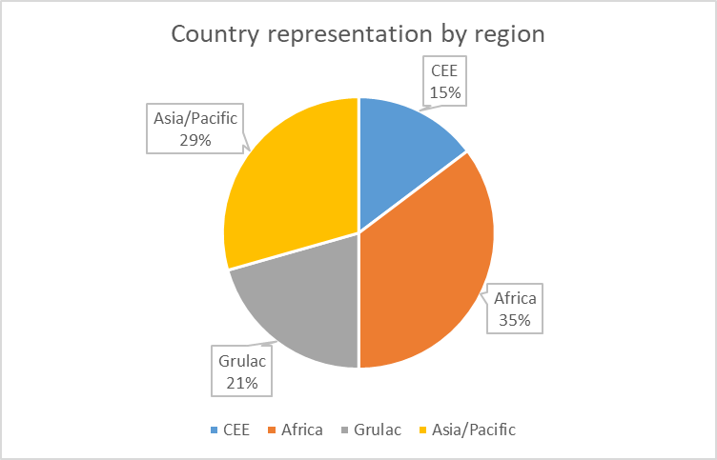

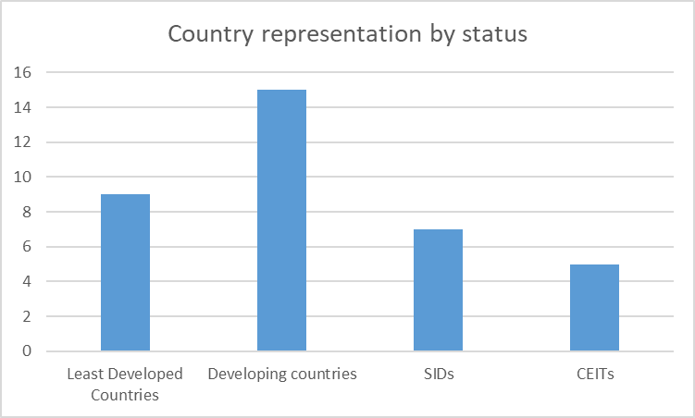
Abbreviations: CEE, Central and Eastern Europe, GRULAC, Latin American and the Caribbean; CEITs, countries with economies in transition; SIDS, small island developing States.

* UNEP/MC/COP.2/1.
https://wedocs.unep.org/bitstream/handle/20.500.11822/12221/Governing%20Council%20Decision%2027-2.pdf?sequence=1&isAllowed=y
http://wedocs.unep.org/bitstream/handle/20.500.11822/17285/K1402364.pdf?sequence=3&isAllowed=y
For the purposes of the Special Programme, institutional strengthening is defined as enhancing the sustainable institutional capacity of Governments to develop, adopt, monitor and enforce policy, legislation and regulation, as well as to gain access to financial and other resources for effective frameworks for the implementation of the Instruments for the sound management of chemicals and wastes throughout their life cycle.
The Special Programme was established in September 2015, at the same time as the establishment of the Special Programme Trust Fund.
https://www.unenvironment.org/explore-topics/chemicals-waste/what-we-do/special-programme/special-programme-executive-board
An advance version of the report of the third meeting of the Executive Board is available at https://www.unenvironment.org/events/un-environment-event/third-meeting-executive-board-special-programme
Available at: https://www.unenvironment.org/explore-topics/chemicals-waste/what-we-do/special-programme/applying-funding-through-special

