UNITED  NATIONS |  | MC
 |  | UNEP/MC/COP.2/INF/10
 | United Nations  Environment  Programme | Distr.: General  10 September 2018  English only
Conference of the Parties to the
Minamata Convention on Mercury
Second meeting
Geneva, 19–23 November 2018
Item 5 (c) of the provisional agenda*
Matters for consideration or action by the Conference of the Parties: mercury waste, in particular consideration of relevant thresholds
Information submitted by nominated experts that may contribute to the development of mercury waste thresholds
Note by the Secretariat
As referred to in the note by the secretariat on the report on the outcome of the open-ended process on waste thresholds called for under article 11 of the Minamata Convention on Mercury (UNEP/MC/COP.2/6), information submitted by nominated experts that may contribute to the development of mercury waste thresholds is set out in the annex to the present note, without formal editing.

Annex
Information submitted by nominated experts that may contribute to the development of mercury waste thresholds
A. List of mercury compounds
- A number of experts provided a list of mercury compounds in relation to waste consisting of mercury or mercury compounds. Table 1 presents a list of mercury compounds provided by one expert with supplementary information provided by other experts.
Table 1: list of mercury compounds in use
Compound name | Formula | Common uses
Mercury(II) Perchlorate | Hg (ClO4)2 | Pyrotechnics industry
Mercury(II) Chlorate | Hg(ClO3)2 | Lab reagent
Mercury(II) Oxide | HgO | antiseptic in pharmaceuticals; component of dry cell batteries; pigment and glass modifier; fungicide; preservative in cosmetics; analytical reagent; formerly used in antifouling paints.
Mercury(I) Chloride | Hg2Cl2 | Also known as Calomel (mercurous chloride, Hg₂Cl₂) is used as a standard in electrochemical measurements and historically in medicine as a purgative and teething compound for babies.
Mercury(I) Nitrite | Hg2(NO2)2 | Lab reagent with other mercury compounds,
Mercury(I) Phosphate | (Hg2)3(PO4)2 | Pharmaceutical uses, fungicide as ethyl mercury phosphate.
Mercury(II) Nitrate Monohydrate | Hg(NO3)2.H2O | Oxidising agent, lab reagent, historical uses in felt manufacture and detonator production
Mercury(I) Carbonate | Hg2CO3
Mercury(II) Chloride  (mercuric chloride) | HgCl2 | Plastics catalyst for conversion of acetylene to vinyl chloride, historical uses in photography, medicine and biological sample preservation. Rat poison, disinfectant, insecticide. Fungicide as phenyl- and ethyl mercury chloride
Mercury(I) Perchlorate | Hg2(ClO4)2 | reagent
Mercury(I) Nitrate | Hg2(NO3)2 | Oxidising agent, lab reagent, historical uses in felt manufacture
Mercury(II) Nitride | Hg3N2 | reagent
Mercury(II) Bromate | Hg(BrO3)2 | Lab reagent – can create explosive mixtures
Mercury(II) Acetate | Hg(C2H3O2)2 | a reagent to generate organomercury compounds from unsaturated organic precursors. Phenyl mercury acetate used as fungicide.
Mercury(I) Sulfate | Hg2SO4 | Lab reagent. Used in water sampling to mask chloride interference. Catalyst for the production of acetaldehyde from acetylene and water (as used historically by Chisso Corporation in Minamata)
Mercury(I) Cyanide | Hg2(CN)2 | Reagent in Koenigs–Knorr reaction for the synthesis of glycosides. Historical use as an antiseptic and in photography. Current use in homeopathy as Hydrargyrum bicyanatum.
Mercury(I) Dichromate | Hg2Cr2O7 | Reagent
Mercury(II) Oxide | Hg2O | Used in pesticide formulations historically
Mercury II Fulminate | Hg2(CNO)2 | Primary explosive compound historically used in detonators and priming caps.
Mercury Sulphide (cinnabar) | Hg2S | Naturally occurring mineral which is the basis of elemental mercury, also historically used in vermillion pigment.
Note: US Environmental Protection Agency’s report to the Congress “Potential Export of Mercury Compounds from the United States for Conversion to Elemental Mercury” in 2009, referred to in a comment from an expert, also includes the following compounds.
- Mercury(II) Iodide (used in laboratory chemistry, veterinary medicine, nuclear particle detection)
- Mercury (II) Selenide (used in electrochemistry)
- Mercury (II) thiocyanate (used in laboratory chemistry, photography)
- Phenylmercury (II) Acetate
- Thimerosal (Sodium Ethylmercurithiosalicylate, used in pharmaceutical)
Other submissions also included lists of mercury compounds without information on specific use, including US Federal Register 82 FR 49569 (October 26, 2017).
- One expert noted that the list is only indicative and non-exhaustive, and provided a list of more than 200 mercury compounds taken from the European Chemicals Agency’s database.
B. List of mercury added products
- A number of experts provided lists of mercury added products in use. These are reproduced in Tables 2, 3 and 3 below. Other information provided by experts includes the following:
- US Federal Register 82 FR 49583, Table 2 (October 26, 2017), available at https://www.gpo.gov/fdsys/pkg/FR-2017-10-26/pdf/2017-23225.pdf;
- the IMERC mercury products data base, available at http://www.newmoa.org/prevention/mercury/imerc/Notification/about.cfm
- Canada mercury product regulations schedule, available at http://www.gazette.gc.ca/rp-pr/p2/2014/2014-11-19/pdf/g2-14824.pdf#page=176.
Table 2: Mercury-added products used for the existing purposes under Japanese regulations
1. Primary batteries (limited to: alkaline button batteries, mercury batteries, zinc-air batteries, silver-oxide batteries, manganese dry-cell batteries, and alkaline dry-cell batteries)  2. Standard cells  3. Switches/relays  4. Fluorescent lamps (including cold cathode fluorescent lamps- CCFL, and external electrode fluorescent lamps- EEFL)  5. High-intensity discharge (HID) lamps  6. Discharge lamps (excluding fluorescent lamps and HID lamps)  7. Cosmetic products  8. Agricultural chemicals  9. Pesticide, biocide, topical antiseptics (excluding pharmaceutical products and agricultural chemicals)  10. Barometers | 11. Hygrometers  12. Liquid manometers  13. Elastic manometers (limited to diaphragm type)  14. Pressure transmitters (limited to diaphragm type)  15. Vacuum gauges  16. Glass thermometers  17. Mercury-filled pressure thermometers  18. Mercury clinical thermometers  19. Mercury sphygmomanometers  20. Temperature fixed-point cells  21. Rubber  22. Pigment  23. Perfume  24. Detonators  25. Fireworks  26. Paints  27. Daguerreotypes  29. Mercury alloy pellets and powder | 29. Boilers (limited to those used in a two phase fluid cycle)  30. Rotating lens assembly of a lighthouse  31. Diffusion pumps  32. Pressure relief devices  33. Dampers  34. Mercury trim and heel adjusting devices  35. X-ray tubes  36. Mercury resistance standards  37. Rotary connectors  38. Infrared detection elements  39. Differential pressure flowmeters  40. Float type densitometers  41. Clinometers  42. Frequency standards  43. Radiation detectors  44. Detector tubes  45. Elapsed time indicators  46. Strain gauge sensors | 47. Coulometers  48. Reference electrodes  49. Gyrocompasses  50. Mirrors  51. Grip dynamometers  52. Pharmaceutical products  53. Polishing agents  54. Arts and crafts  55. Formulation of mercury  56. Formulation of mercury (I) chloride  57. Formulation of mercury (II) chloride  58. Formulation of mercury (II) iodide  59. Formulation of mercury (I) nitrate  60. Formulation of mercury (II) nitrate  61. Formulation of mercury (II) thiocyanate  62. Formulation of phenylmercury (II) acetate

Table 2: Product types that require recovery of mercury or specific safe disposal measures being considered in the Republic of Korea
- Items for priority management (18 items): for promoting mercury recovery and recycling
1. switches/relays, 2. (thermometer, sphygmomanometers, pressure gauge etc), 3. mercury batteries, 4.fluorescent lamps, 5. dental amalgam, 6. high pressure mercury vapor lamps, 7. (CCFL and EEFL), 8. rotating lens assembly of a lighthouse, 9. mercury trim and heel adjusting devices, 10. differential pressure flow meters, 11. floating type densitometers, 12. clinometers, 13.elapsed time indicators, 14. strain gauge sensors, 15. coulometers, 16. gyrocompasses, 17. grip dynamometers, 18. UV lamps (Short-Arc lamps)
* Cosmetics, pesticides, biocides and topical disinfectants are subject to the Minamata Convention, however, these are excluded from mercury recovery list because they are released to the environment when users used these products with a little content of mercury.
- Items proposed to management in addition (18 items): for mercury treatment and safe disposal
1. HID lamps (high intensity discharge lamps), 2. discharge lamps (except for fluorescent lamps and HID lamps) 3. batteries (except for mercury batteries), 4. pesticide, 5. mercury resistance standards, 6. temperature fixed-point cells, 7. frequency standards, 8. Boilers (limited to those used in a two phase fluid cycle), 9. standard cells, 10. pharmaceuticals, 11. medicine manufactured with mercury, 12. medicine manufactured with mercury (I) chloride, 13.medicine manufactured with mercury(II) chloride, 14. medicine manufactured with mercury (II) iodide, 15.medicine manufactured with mercury (I) nitrate, 16.medicine manufactured with mercury(II) nitrate, 17. medicine manufactured with mercury (II) thiocyanate, 18.medicine manufactured with phenyl mercury(II) acetate
Table 3: List of mercury added products provided from other experts
List 1:
1-Equipment
Lamps (high pressure or fluorescent)
Some WEEE (switches)
Some batteries
Measuring and controlling devices
Distress flares
Airbags
Specific devices/equipment/mechanical pieces with mercury welds
2-Products
Dental amalgam
Some paints
Some cosmetics
Some homeopathic products
Some pesticides, biocides and topical antiseptics
Some catalysts
Some preservatives (vaccines, paints, cosmetics)
Some chemical intermediate
List 2:
Fluorescent Lamps (including Tanning Bed Lamps, CFLs, LFLs)
High pressure mercury vapor lamps
Cold Cathode Fluorescent Lamps (CCFLs)
External Electrode Fluorescent Lamps (EEFL)
Mercury-Containing Switches (Lighting, Refrigerators, Freezers, vehicles, aviation and marine applications)
Mercury-Containing Thermostats
Silent Wall Switches
Commercial/Industrial Heating & Cooling Equipment
Mercury-Containing Float Switches
Mercury-Containing Gas-Fired Devices with Pilot Lights and Flame Sensors (ex. Gas Ranges and Ovens)
Mercury-Containing Manometers/Barometers
Batteries
Cosmetics (skin lightening soaps and skin creams)
Pesticides, biocides, disinfectants and antiseptics
Measuring devices (barometers, hygrometers, thermometers, sphygmomanometers)
Dental amalgam.
C. Data on mercury content in waste contaminated with mercury or mercury compounds
- One expert submitted information on mercury concentration in different types of waste in Japan. The submitted information is reproduced as Figure 1. Japan has identified that mercury is recovered from wastes contaminated with mercury or mercury compounds whose total mercury concentration is equal to or higher than 1000 ppm (see figure 1). To ensure mercury recovery from such wastes when mercury demand decreases, the Waste Management Act requires mercury recovery from wastes contaminated with mercury or mercury compounds whose total mercury concentration is equal to or higher than 1000 ppm. Mercury is also recovered from some wastes contaminated with mercury or mercury compounds whose mercury concentration is lower than 1000 ppm.
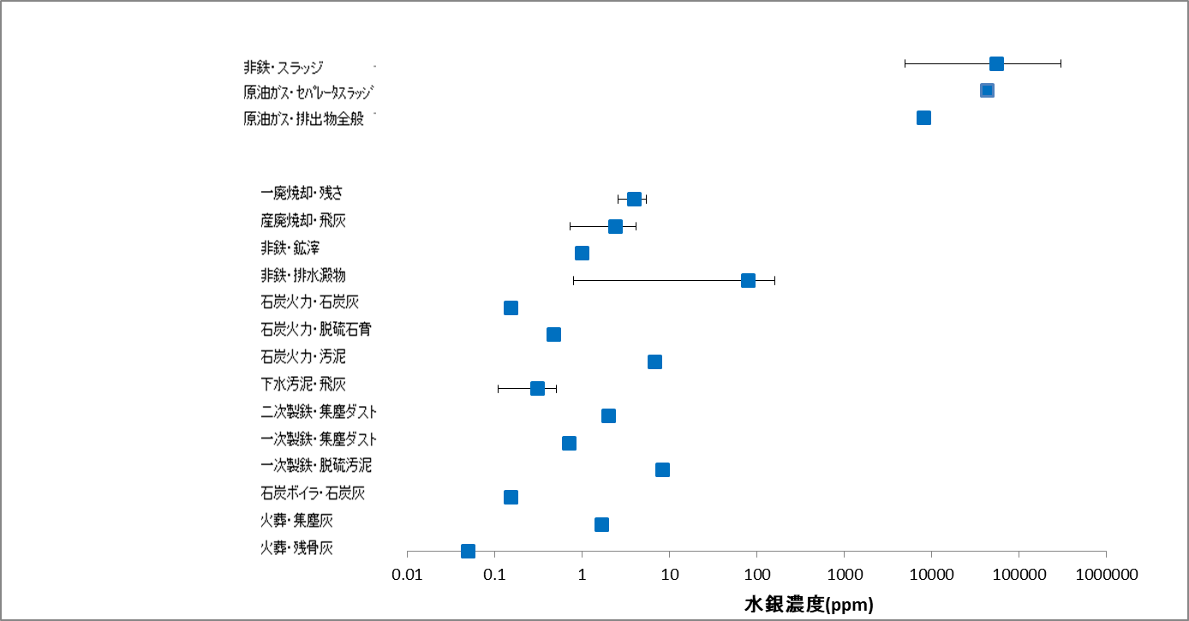
Concentration of mercury (ppm)
Collected dust from crematories
Residual bone ash from crematories
Residues from municipal waste incinerators
Fly ash from industrial waste incinerators
Slags from non-ferrous metal smelting plants
Sediment in wastewater from non-ferrous metal smelting plants
Coal ash from coal-fired power plants
Flue gas desulfurization gypsum from coal-fired power plants
Sludge from coal-fired power plants
Fly ash from sewage sludge incinerators
Collected dust from secondary steel plants
Collected dust from primary steel plants
Flue gas desulfurization sludge from primary steel plants
Coal ash from coal-fired industrial boilers
Flue gas treatment sludge from non-ferrous metal smelting plants
Separator sludge from crude oil/gas production
Wastes in general from crude oil/gas production
Figure 1: Examples of wastes contaminated with mercury or mercury compounds and their mercury concentrations
Source: Committee on the environmentally sound management of mercury wastes, Working Group on the recovery and disposal of mercury. (2014). Report on the environmentally sound management of mercury wastes (in Japanese).

- One expert submitted information on mercury content of waste in the Republic of Korea.
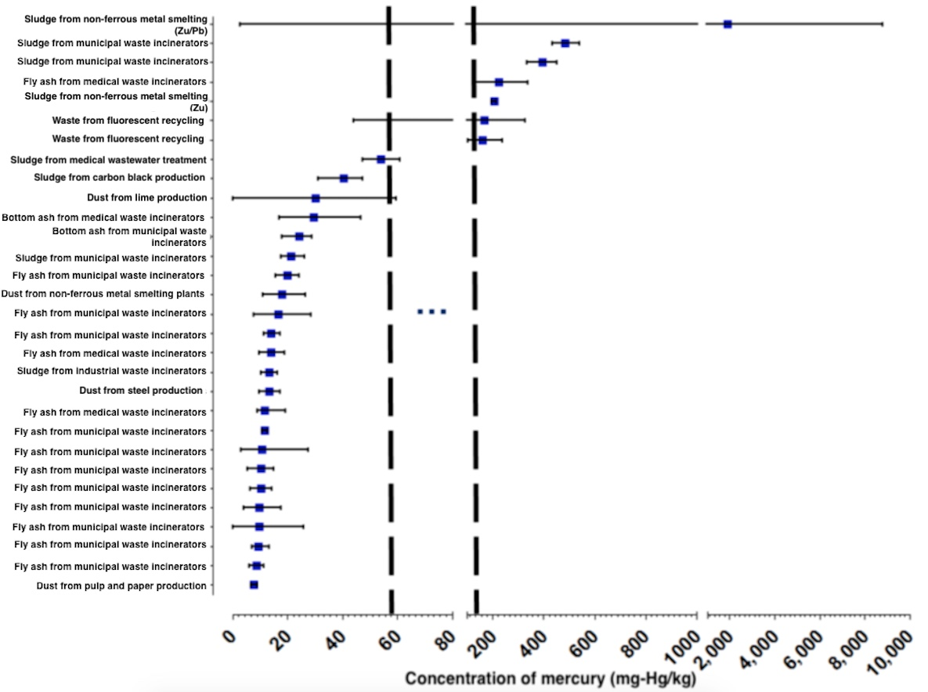
Figure 2: Mercury concentrations of the industrial wastes generated in ROK
(Blue squares are the mean values and error bars are the standard deviations)
- One expert submitted information from mercury waste inventory in Sweden. As reproduced in Figures 2 and 3, the Swedish data show that for a concentration limit of 1 % mercury (10 000 mg/kg), the amount would equal ~697 tonnes of mercury contained in ~9 800 tonnes of waste (modified from SEPA 2003). If on the other hand a threshold value of 0,5 % mercury (5000 mg/kg) is applied, the amount would equal ~772 tonnes of mercury in ~23 000 tonnes of waste; and for a threshold value of 0,1 % mercury (1000 mg/kg) the corresponding amounts are 1052 tonnes of mercury in 133 000 tonnes of waste. The numbers are presented in the diagrams below. Figure 2 shows the cumulative amounts of mercury and amount of waste in descending order. The diagram clearly shows that a large fraction of the mercury inventory is contained in the wastes with the highest concentrations. About 97 % of the mercury is found in wastes with a mercury concentration of 1000 mg/kg or higher. From the second diagram it is clear that wastes with a mercury concentration in the range 1000-5000 mg/kg constitutes a significant source of mercury (280 tonnes).
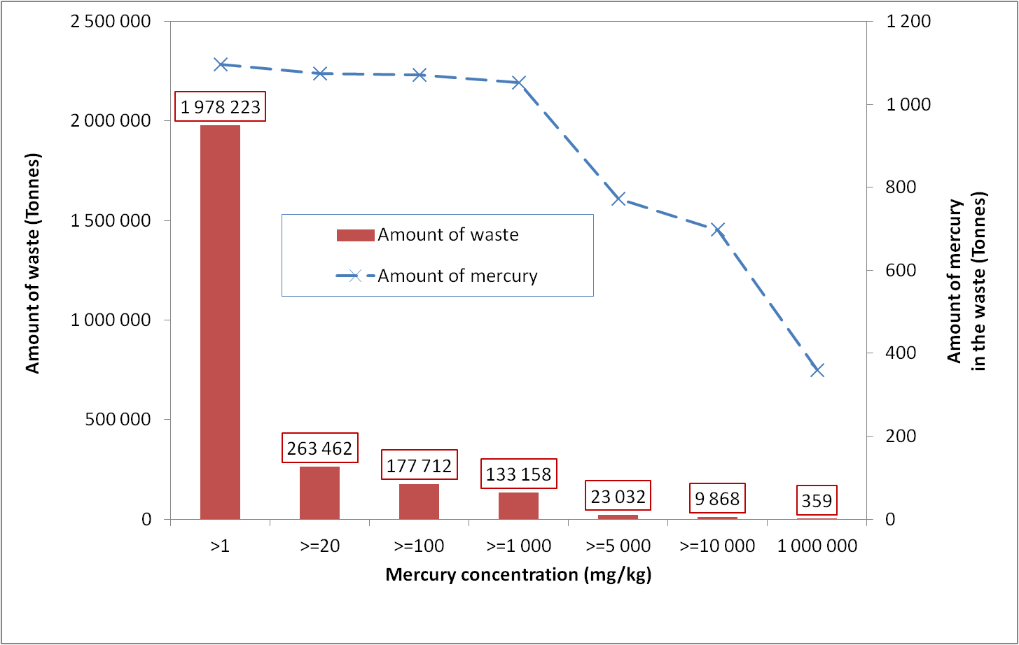
Figure 3: Inventory of Swedish mercury waste (modified from SEPA 1997).
The diagram shows cumulative amounts in descending order
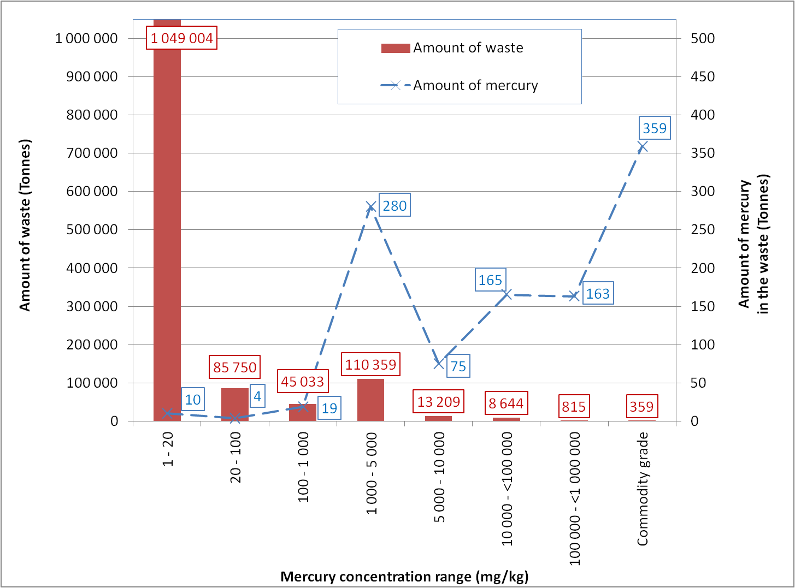
Figure 4: Inventory of Swedish mercury waste (modified from SEPA 1997). The diagram shows the amounts within specific mercury concentration ranges.
- The previous compilation document included data submitted by experts on mercury concentration in different types of waste in Japan and Sweden. One expert submitted information from a study in the Republic of Korea. Out of 394 samples, eight samples contained over 150 mg/Kg of mercury, and these 2% of wastes took up almost 90% of the mercury release from all of the industrial wastes.
D. Existing thresholds in national legislation
- One expert submitted information on existing mercury thresholds in the waste ordinance in Switzerland as follows.
Table 5: Mercury waste thresholds in Switzerland
Annex 3 (ref. in article 17) | Requirement for demolition and excavation material (unpolluted) | 0,5 mg Mercury / kg dry matter
Annex 3 (ref. in article 17) | Requirement for demolition and excavation material (subject to further use in construction materials) | 1 mg Mercury / kg dry matter
Annex 4 (ref. in article 24) | Requirement for waste, used as raw material in cement and concrete production  1) Use of waste as raw material and raw mix corrective in cement clinker production | 1 mg Mercury / kg dry matter
 | 2) Use of waste as alternative fuel in cement clinker production | 1 mg Mercury / kg dry matter
Annex 5 | Requirement for waste put in a landfill  1) Type B landfill (inert waste) | 2 mg Mercury / kg dry matter  0,01 mg Mercury / Litre dry matter (leaching)
 | 2) Type C landfill (solidified fly ashes of MSWI1) | The total content of mercury may not exceed 5 mg / kg dry matter for metal-containing, inorganic and badly soluble waste
 | 3) Type D landfill (slag of MSWI) | 5 mg Mercury / kg dry matter
 | 4) Type E landfill (other waste, slightly reactive) | 5 mg Mercury / kg dry matter

- One expert provided the following information on the regulations in China.
The method of identifying hazardous waste in China
According to 《Identification standards for hazardous wastes General specifications》（GB5085.7-2007）, the hazardous wastes are those wastes that are listed on national hazardous waste list, or the ones that are identified having one or more hazardous characteristics, including corrosivity, toxicity, flammability, reactivity and infectivity based on national hazardous waste identification criteria and methods, and those solid wastes that could not find proof to prove they had none of above mentioned hazardous characteristics, also might be identified as a hazardous waste.
For the identification of hazardous wastes that containing mercury, leaching toxicity and total content toxic substances are usually used, in addition to the identification of corrosivity, reactivity and flammability.
（1） Identification method of leaching toxicity and the threshold
According to the requirement of the standard methods of Solid waste- Extraction procedure for leaching toxicity- sulphuric acid and nitric acid method（HJ/T299-2007）, preparation methods of the leaching test solution for mercury and other metals are as follows: Prepare the extracting solution by adding the mixture of concentrated sulfuric acid and concentrated nitric acid in a 2:1 ratio (w/w) into reagent water, to adjust the pH value to 3.20±0.05. Weigh the waste samples that going to extract, and calculate the volume of extract required according to a liquid-solid ratio of 10:1. If the total mercury concentration in the leachate does not exceed the threshold limit (0.1mg/L), and no alkyl mercury is detected (i.e. Methyl mercury <10ng/L; ethyl mercury <20ng/L), then the solid waste will be regarded as having no hazardous characteristics of leaching toxicity.
（2）Identification method for total toxic substances and its threshold
According to Identification standards for hazardous wastes-Identification for toxic substance content（GB 5085.6-2007），there are five annexes of chemical compounds with different toxicity, in the five annexes, there is only in annex A and Annex B that can find the mercury compound, but none in others. In annex A we can find mercuric iodide, thiocyanate mercury, mercuric chloride, mercuric cyanide and mercury nitrate, etc, and the threshold 0.1% is applies for the total content of above mentioned mercury compound. In annex B, only can found mercurous bromide, and the threshold is 3%. For mixtures, the sum of the toxicity of all the components in all annexes is taken into account. If a mercury waste meet any of such three situations, it can be identified as a (mercury) hazardous waste.
4.2 The relevant regulations of mercury content or waste mercury related to waste management and disposal in China
（1）the criteria for entering the municipal solid waste (MSW) landfills
According to Standard for Pollution Control on the Landfill Site of Municipal Solid Waste（GB18485-2014）, if the concentration of hazardous ingredients in the leachate obtained according to The Solid waste – Extraction procedure for leaching toxicity – Acetic acid buffer solution method (HJ / T300-2007) are lower than the thresholds setting in GB18485-2014 , municipal solid waste incineration (MSWI) fly ash, medical waste incineration residue, and general industrial solid waste, can be disposed in MSW landfills in a separated space. Among them, the threshold of mercury is 0.05mg/L.
（2）co-processing waste in Cement kiln
Wastes containing mercury are prohibited from being co-processed in cement kilns based on the requirements of Standard for pollution control on co-processing of solid wastes in Cement kiln（GB30485-2013）. The solid waste prohibited from entering cement kilns and which is related to mercury waste are as follows:
（a）spent batteries, used household appliances and electronic devices that are not dismantled;
（b）Thermometers, sphygmomanometers, fluorescent tubes and switches containing mercury;
（c）wastes unidentified wastes and with unknown characteristics.\
（3）regulation related to identification of Contaminated Soil
According to the requirement of Identification standards for solid wastes-General rules（GB34330-2017）, in the activities of contaminated site remediation and disposal, contaminated soil will be managed as solid wastes if it is handled, disposed or utilized in the following ways: （a）landfill；（b）incineration；（c）cement kiln
co-processing；（d）used to produce construction materials, such as bricks, tiles and road materials, etc.

- Another expert provided information on the leaching criteria in Australia and the European Commission.
- It should be noted that a review of available information on thresholds for the identification of mercury wastes used by countries and regions is included in a report of an informal process lead by Japan on mercury waste threshold (UNEP/MC/COP.1/INF/10). Any update information in this regard would be helpful.
E. Proposed threshold values
- One expert provided information on threshold values used in Swedish waste and soil regulations, and suggested threshold values as summarised in Figure 4.

Figure 4: Suggested threshold values for mercury concentrations to be used when selecting ESM method for different mercury wastes.
Another expert proposed concentration limit is 25 mg of mercury or mercuric substances per kg of dry mass for solid product or waste, and 25 mg of mercury or mercuric substances per kg of liquid product or waste, based on the Global Harmonized System of chemical classification of substances. The same expert submitted an impact assessment of this proposed concentration limit.

* UNEP/MC/COP.2/1.
When "formulations" of mercury and mercury compounds listed from No.55 to No.62 are used as reagents, they are considered as mercury-added products only if they are processed (e.g. diluted and mixed) for the specific purpose under the Act on Preventing Environmental Pollution of Mercury.
SEPA (2003): A Safe Mercury Repository, English translation of the Swedish Government Official Report 2001:58 produced by the Swedish Environmental Protection Agency. Report 8105.
SEPA (1997): Final disposal of mercury – Mercury containing waste in Sweden – Inventory, characterization and prioritizing. Karin Pers, Lars Gunnar Karlsson, Lars Olof Höglund, Kemakta Konsult AB, report to Swedish Environmental Protection Agency (SEPA) Rapport 4768 (in Swedish).
https://www.admin.ch/opc/fr/classified-compilation/20141858/index.html
http://www.mercuryconvention.org/Meetings/COP1/tabid/5544/language/en-US/Default.aspx

