UNITED  NATIONS |  | MC
 |  | UNEP/MC/COP.1/INF/4
 | United Nations  Environment  Programme | Distr.: General  7 July 2017  English only
Conference of the Parties to the
Minamata Convention on Mercury
First meeting
Geneva, 24–29 September 2017
Item 5 (a) (iv) of the provisional agenda*

Matters for action by the Conference of the Parties at its first meeting; matters stipulated under the Convention: the measures to give effect to the arrangements for the financial mechanism referred to in article 13
Special Programme to support institutional strengthening at the national level for implementation of the Basel, Rotterdam and Stockholm conventions, the Minamata Convention on Mercury and the Strategic Approach to International Chemicals Management: implementation of the programme since its establishment
I. Introduction
- In view of the increased need for sustainable, predictable, adequate and accessible financing for the chemicals and waste agenda, the Executive Director of the United Nations Environment Programme made a proposal for the establishment of an integrated approach to financing the sound management of chemicals and waste to the Governing Council of the United Nations Environment Programme (UNEP) at its twenty-seventh session, in February 2013. In its decision 27/12, on chemicals and waste management, the Governing Council welcomed the integrated approach and underscored that the three components of an integrated approach, mainstreaming, industry involvement and dedicated external finance, were mutually reinforcing and were all important for the financing of the sound management of chemicals and waste.
- At its first session, in June 2014, in its resolution 1/5 on chemicals and waste, the United Nations Environment Assembly of the United Nations Environment Programme reiterated its welcome of an integrated approach to the financing of chemicals and waste management and adopted the terms of reference for a special programme, to be established and administered by UNEP and funded through voluntary contributions, to support institutional strengthening at the national level to enhance the implementation of the Basel Convention on the Control of the Transboundary Movement of Hazardous Wastes and Their Disposal, the Rotterdam Convention on the Prior Informed Consent Procedure for Certain Hazardous Chemicals and Pesticides in International Trade, the Stockholm Convention on Persistent Organic Pollutants, the Minamata Convention on Mercury and the Strategic Approach to International Chemicals Management. The Special Programme is one of two complementary elements of dedicated external financing under the integrated approach; the Global Environment Facility (GEF) is the other element.
- The Special Programme was subsequently established and is part of subprogramme 5, on chemicals and waste, in the United Nations Environment Programme programme of work; it provides dedicated support for institutional strengthening at the national level aimed at facilitating the implementation of the Basel, Rotterdam and Stockholm conventions, the Minamata Convention and the Strategic Approach. It addresses in particular expected accomplishment (a) of that subprogramme that: “countries increasingly have the necessary institutional capacity and policy instruments to manage chemicals and waste soundly, including the implementation of related provisions in the multilateral environmental agreements.”
- The terms of reference of the Special Programme stipulate that countries will be eligible for support from the Programme as follows:
- Support from the Special Programme will be available for developing countries, taking into account the special needs of least developed countries and small island developing States, and for countries with economies in transition, with priority given to those with least capacity;
- Applicants will be eligible if they are party to any one of the relevant conventions or have demonstrated that they are in the process of preparing for ratification of any one of the conventions;
- Applications are to include identification of the associated domestic measures to be taken to ensure that the national institutional capacity supported by the Special Programme is sustainable in the long term.
- The terms of reference also provide for the following operational arrangements:
- Applications should be outlined within the context of an overall country approach to strengthening institutional capacity;
- Applications should contain proposed measures and performance targets and information relating to long-term sustainability;
- Cumulative allocations to a country should be decided by the Executive Board, based on the contributions received and the needs expressed in the applications submitted. Of that total, an amount not exceeding 13 per cent may be retained for administrative purposes;
- Beneficiary countries will contribute resources equal to the value of at least 25 per cent of the total allocation. The Executive Board may reduce that percentage, commensurate with consideration of the specific national circumstances, capacity constraints, gaps and needs of the applicant;
- Beneficiary countries are to submit annual reports on progress achieved; a final report and financial audit, including a full accounting of funds used and an evaluation of outcomes, as well as evidence of whether performance targets have been met, are to be submitted upon completion of each project.
II. Implementation
A. Executive Board of the Special Programme
- The Executive Board is the decision-making body overseeing the Special Programme. The Executive Board reflects a balance between donors and recipients. Members of the Board serve two-year terms. The Executive Board comprises:
- Four representatives of recipient countries, reflecting equitable geographical representation, drawn from the following United Nations regional groupings: Africa, Asia-Pacific, Central and Eastern Europe and Latin America and the Caribbean. In addition, the Executive Board will have one representative from a least developed country or a small island developing State on a rotational basis;
- Five donor representatives that are not recipient countries.
- The Executive Board has been established with representatives of the following:
- Recipient countries: Kenya (Africa), Pakistan (Asia-Pacific), the former Yugoslav Republic of Macedonia (Central and Eastern Europe), Brazil and Argentina (Latin America and the Caribbean – sharing the two-year term), and Yemen (least developed country);
- Donor countries and regional economic integration organizations: European Union, Finland, Germany, Sweden and the United States of America.
- The Executive Board at its first meeting, held in February 2016 in Geneva, nominated Brazil, representing recipient countries, and Finland, representing donor countries, as co-chairs of the Executive Board. With the handover of the Board membership for the Latin America and Caribbean region from Brazil to Argentina in early February 2017, the Executive Board held a teleconference in April 2017 to nominate a new co-chair representing recipient countries. The former Yugoslav Republic of Macedonia was subsequently nominated as co-chair representing recipient countries for the rest of the two-year term ending on 2 February 2018.
B. First meeting of the Executive Board
- The first meeting of the Executive Board was held on 2 and 3 February 2016 in Geneva. Significant progress was made during the meeting, with agreement reached on rules of procedure for the operations of the Executive Board, application guidelines and application forms. The Executive Board also agreed to launch the first round of applications on 4 April 2016, with a deadline for the submission of applications of 4 July 2016.
C. First round of applications for the Special Programme
- In preparation for the launch of the first round of applications, the application guidelines and application forms were finalized following recommendations by the Executive Board at its first meeting. The Special Programme website was updated to include information on the outcomes of the first meeting of the Executive Board, an update on donors and information on the launch of the first round of applications. Announcements for the launch of the first round of applications were also made by the secretariats of the Basel, Rotterdam, Stockholm and Minamata conventions and the Strategic Approach through their websites and through Basel, Rotterdam, Stockholm and Minamata convention and Strategic Approach information broadcasts.
- A series of outreach events on the Special Programme was undertaken by the Programme secretariat following the launch of the first round of applications to provide visibility on the donors to the Special Programme, including through:
- A technical briefing entitled “Financing under the Minamata Convention” held in the margins of the seventh session of the intergovernmental negotiating committee to prepare a global legally binding instrument on mercury, 9 March 2016, Dead Sea, Jordan;
- The first meeting of the Bureau of the International Conference on Chemicals Management for its fifth session, 16 and 17 March 2016, Dead Sea, Jordan;
- A chemicals and waste briefing for the permanent missions to the United Nations in Geneva, 29 April 2016;
- Webinars on the first round of applications hosted by the secretariat of the Basel, Rotterdam and Stockholm conventions, as follows:
- 25 April 2016 for Asia and the Pacific and Africa;
- 28 April 2016 for Asia and the Pacific and Africa;
- 3 May 2016 for small island developing States and Latin America and the Caribbean;
- 18 May 2016 for Latin America and the Caribbean (in Spanish);
- 19 May 2016 for Central and Eastern Europe and Central Asia (in Russian);
- 19 May 2016 for Francophone Africa (in French);
- 20 May 2016 for Central and Eastern Europe and Central Asia;
- The forty-fifth meeting of the Inter-Organization Programme for the Sound Management of Chemicals (IOMC), 11and 12 May 2016, Geneva;
- A global workshop on enhancing national cooperation and coordination for the implementation of the Basel, Rotterdam and Stockholm conventions, 21–23 June 2016, Geneva;
- A meeting of the Bureau of the Conference of the Parties to the Rotterdam Convention, 14 June 2016, Geneva;
- A meeting of the Bureau of the Conference of the Parties to the Stockholm Convention, 28 and 29 June 2016, Geneva;
- A meeting of the Bureau of the Conference of the Parties to the Basel Convention, 11 and 12 July 2016, Geneva;
- A meeting of the Bureau of the Minamata Convention, 24 and 25 August 2016, Livingstone, Zambia;
- A subregional workshop on enhancing national cooperation and coordination for the implementation of the Basel, Rotterdam, Stockholm conventions, the Bamako Convention on the Ban of the Import into Africa and the Control of Transboundary Movement and Management of Hazardous Wastes within Africa and the Sustainable Development Goals in the countries of the Southern African Development Community, 6 September 2016, Manzini, Swaziland;
- A chemicals and waste briefing for the permanent missions to the United Nations in Geneva, 30 November 2016.
- Information on the Special Programme was also included in the March 2016 and May 2016 newsletters of the Chemicals and Waste Branch of the UNEP Division of Technology, Industry and Economics.
- From April to July 2016, the Special Programme secretariat responded to a large number of queries from developing countries and countries with economies in transition relating to their applications.
- Applications were received from the end of June 2016 until the deadline of 4 July 2016. A total of 54 applications were received from 45 countries. Acknowledgements of the applications were sent no later than a week after receipt of the applications. Information on the regions and types of countries from which applications were received is provided in the annex to the present note.
- An internal task team consisting of representatives of the secretariats of the Basel, Rotterdam and Stockholm conventions, the Minamata Convention, the Strategic Approach and GEF was established by the Executive Board at its second meeting. Its role is to assist the Special Programme secretariat to appraise the applications received from developing countries and countries with economies in transition.
- Four meetings of the internal task team, comprising representatives of the Basel, Rotterdam and Stockholm convention secretariat, the interim secretariat of the Minamata Convention and the Strategic Approach secretariat, were convened in July and August 2016 to undertake a technical review of the applications received.
- To support the work above, the secretariat engaged an intern from June to August 2016. In addition, a Junior Professional Officer assisted the Special Programme secretariat for six months in the processing of applications for approval by the Executive Board and the management of approved allocations over the coming year.
- Between July and September 2016 the secretariat assessed the eligibility and completeness of the applications received, as a result of which 42 applications were presented to the Executive Board for its consideration and approval.
D. Second meeting of the Executive Board
- The second meeting of the Executive Board was held from 11 to 13 October 2016 in Bangkok. The meeting was attended by the full complement of Board members. Members representing the following recipient countries attended the meeting: Brazil, Kenya, Pakistan, the former Yugoslav Republic of Macedonia and Yemen. Members representing the following donors also attended: European Union, Finland, Germany, Sweden and the United States. In addition, a number of Governments, IOMC members (UNEP, the United Nations Institute for Training and Research and the World Health Organization), the secretariat of the Basel, Rotterdam and Stockholm conventions, the interim secretariat of the Minamata Convention, the Strategic Approach secretariat and the GEF secretariat were represented as observers.
- The main objective of the meeting was to review the eligible and complete applications submitted for the first round of applications. The outcome of the review resulted in the following seven approved projects for this pilot round, amounting to $1.75 million, taking into consideration regional balance and the special needs of least developed countries and small island developing States:
- Benin: Legal and institutional strengthening for the sound management of chemicals in Benin;
- United Republic of Tanzania: Strengthening institutional capacity for the sound management of chemicals and waste in the United Republic of Tanzania;
- Iraq: Development and strengthening of the institutional structure for the management of chemicals and waste in Iraq;
- Kyrgyzstan: Strengthening capacities for national implementation of chemicals and waste-related international agreements;
- Ukraine: Strengthening the enforcement of the Rotterdam Convention in Ukraine and building capacity to counteract illegal trafficking of chemicals;
- Argentina: Strengthening national capacity for the sound management of chemicals and waste;
- Dominican Republic: Strengthening institutional capacity for the implementation of the Basel, Rotterdam and Stockholm conventions, the Minamata Convention and the Strategic Approach in the Dominican Republic.
- The Board agreed that the second round of applications would take place in February 2017. The third Executive Board meeting is scheduled for the end of November or beginning of December 2017.
E. Second round of applications for the Special Programme
- The second round of applications for funding from the Special Programme was launched on 22 February 2017, with a deadline for the submission of applications of 20 June 2017.
- To facilitate the application process, revised application guidelines and application forms were developed. The application guidelines provide detailed steps on how to complete the application forms and what information must be submitted. The following guidelines and forms are available on the Special Programme website:
- Application guidelines;
- Application form IA– project summary;
- Application form IB – project description;
- Application form II – project budget.
- Announcements for the launch of the second round of applications were also made by the secretariats of the Basel, Rotterdam and Stockholm conventions, the Minamata Convention and the Strategic Approach through their websites and through Basel, Rotterdam and Stockholm convention, Minamata Convention and Strategic Approach information broadcasts.
- A series of outreach events on the Special Programme will be undertaken following the launch of the second round of applications, starting with information sharing events during the next meetings of the conferences of the Parties to the Basel, Rotterdam and Stockholm conventions. Further information on forthcoming outreach events will be posted on the Special Programme website.
- In addition, the special programme secretariat has provided technical support and responded to a large number of queries from developing countries and countries with economies in transition to assist them in the development of their application packages.
- A total of 40 applications were received from 37 countries by the 20 June 2017 deadline. Acknowledgements of the applications were sent no later than one week after their receipt. Information on the regions and types of countries from which applications were received is provided in the annex to the present note.
- A meeting of the internal task team, attended by representatives of the secretariat of the Basel, Rotterdam and Stockholm conventions, the interim secretariat of the Minamata Convention, the Strategic Approach secretariat and the GEF secretariat, was convened at the end of June 2017 to verify that the activities proposed in the applications were consistent with the objectives and scope of the Special Programme. The applicants will be informed of the outcome of this review and requested to respond to any comments or questions of the internal task team resulting from the review.
F. Special Programme funding status
- The generous contributions of donors to the Special Programme trust fund and its operations are greatly appreciated. The following table provides updated information on donor contributions to the Special Programme trust fund in 2015 and 2016. In addition, some donors have provided financial resources for the operations of the Special Programme (for example, the convening of the Executive Board meetings, outreach and communications) and the Special Programme secretariat. Three new positions (P-3 Programme Officer, P-2 Associate Programme Officer and G-5 Administrative Officer) within the secretariat will be filled in 2017.
Contributions and pledges received 2015−2016 (as at February 2017)
Donor | Total amount pledged/contributed
Austria | €40 000
European Union | €11 000 000
Finland | €200 000
Germany | €360 000
Sweden | $2 680 000
Netherlands | €60 000
United States | $1 250 000
Total contributions and pledges | $16 000 000
- In line with the Special Programme terms of reference, all signatories and parties to relevant conventions and other Governments with the capacity to do so, as well as the private sector, including industry, foundations and non-governmental organizations and other stakeholders, are encouraged to contribute to the Special Programme trust fund.

Annex
Regions and types of countries from which applications were received in the first round of applications
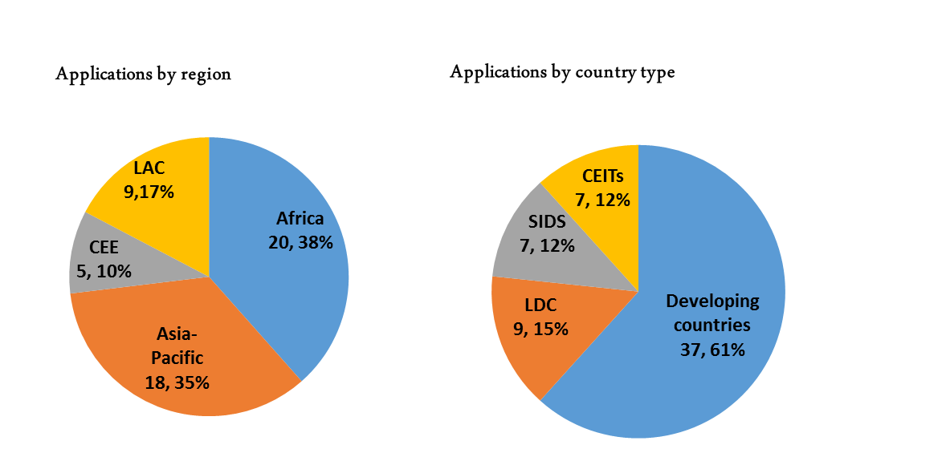
Regions and types of countries from which applications were received in the second round of applications
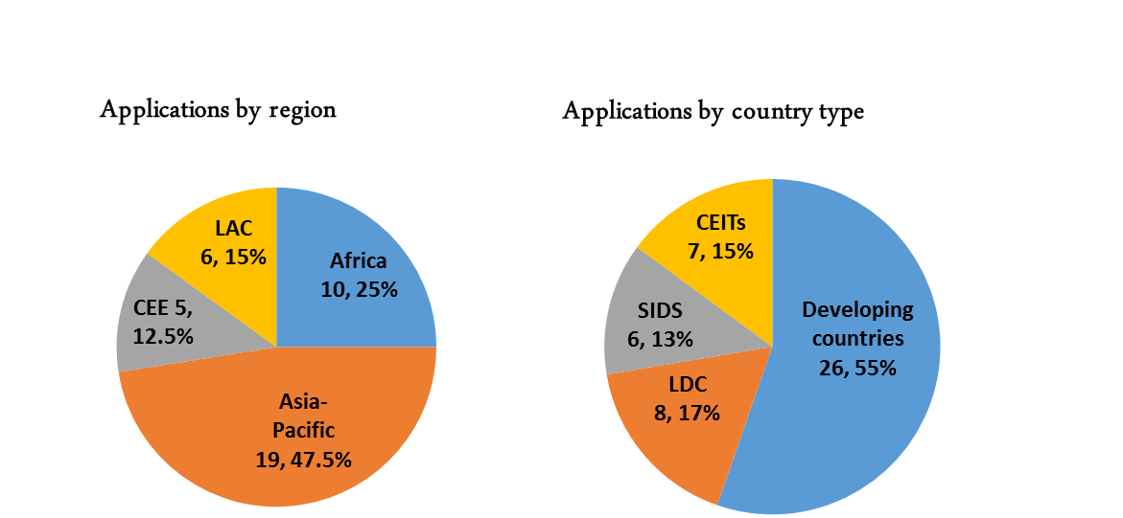
Abbreviations: LAC, Latin American and the Caribbean; CEE, Central and Eastern Europe; CEITs, countries with economies in transition; SIDS, small island developing States; LDCs, least developed countries.

* UNEP/MC/COP.1/1.
The report of the first meeting of the Executive Board is available from http://web.unep.org/chemicalsandwaste/special-programme.
An advance version of the report of the second meeting of the Executive Board is available from http://web.unep.org/chemicalsandwaste/special-programme.

